Project Number: 653477
Project Acronym: ASTERICS
Project title: Astronomy ESFRI & Research Infrastructure Cluster

Periodic Technical Report
Part B

Period covered by the report: from 01/05/2018 to 30/04/2019
Periodic report: 3rd

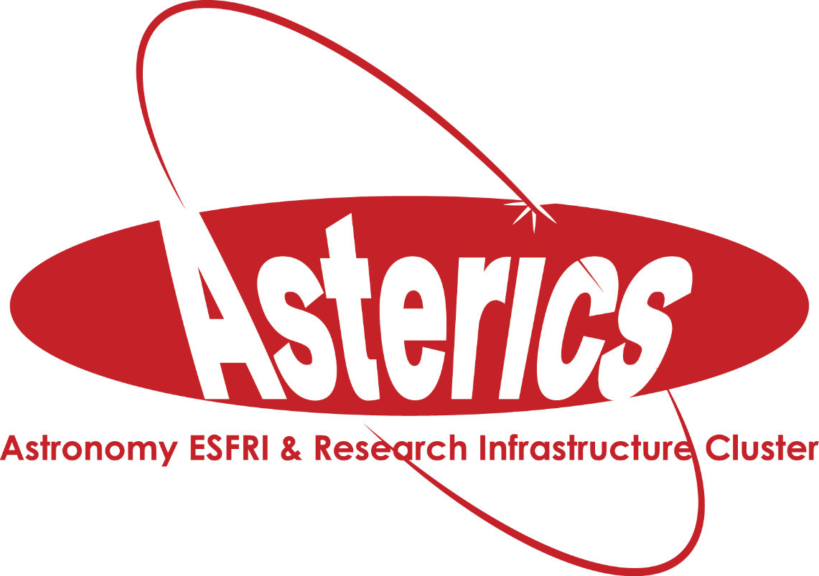
Project number: 653477
Project acronym: ASTERICS
Project title: Astronomy ESFRI & Research Infrastructure Cluster

Period Technical Report
Part B
Period covered by the report: 1 May 2018 – 30 April 2019
Periodic report : 3rd

Table of Contents
Table of Contents 2
1 Explanation of the work carried out and overview of the progress 3
1.1 Objectives 5
1.2 Explanation of the work carried out 11
1.2.1 WP1 Management 11
1.2.2 WP2 DECS 17
1.2.3 WP3 OBELICS 22
1.2.4 WP4 DADI 33
1.2.5 WP 5 Cleopatra 44
1.3 Impact (project as a whole) 49
2 Update of the plan for exploitation and dissemination of results 52
3 Deviations from Annex 1 and Annex 2 54
3.1 Tasks 54
3.2 Use of resources 56
3.2.1 WP2 DECS 56
3.2.2 resources per partner 56
3.2.3 Unforeseen subcontracting 59
3.2.4 Unforeseen use of in kind contribution from third party against payment or free of charges 60
4 Lessons learned 61
5 ANNEXES 63
5.1 Report of AEAB meeting of 26 Nov 2018 63
5.2 Final report of Policy Forum 65

Explanation of the work carried out and overview of the progress
The ASTERICS project was originally set up around four astronomy ESFRI facilities (SKA, CTA, KM3NeT and ELT). In the final project year (2018-2019) we officially incorporated the European Solar Telescope (EST) to the project. The ASTERICS Consortium consists of universities and research institutes with groups of researchers and developers that are linked to one or more of these ESFRI facilities. To bring EST into the project, we welcomed the Kiepenheuer Institut für Sonnenphysik (KIS) into the consortium.
One major task at the beginning of the project was to bring together people from these four distinct research areas, as they had not worked together on such a large scale before. These groups have evolved very different cultures and ways of collaborating. The integration within the overall project of the various groups progressed and participants were, in parallel to the developments for their own facility, more and more thinking about the possible implementation of their work in other facilities. We reported this in PR1 as a big achievement so early into the project. We can report now that this continued to enlarge during the project and it looks like this will continue for several years as nice results have come from it and several groups have established good contacts for collaboration and information sharing. The VO meetings included more data providers and developers and users from new wavelengths and messengers.
Around data and software development three well attended and appreciated schools and workshops were organised. The schools attracted many young researchers from outside the project partners. Participants advertised under colleagues, gave local courses on the topics, or returned to the schools as tutors and some tutors came back to teach again. This shows the success of the schools. Citizen Science experiments were successfully launched and concluded. As the final meeting of the project, we organised a Multi-messenger astrophysics workshop to bring together scientists and developers to show results and possibilities and developments. The closing day was a follow-up meeting on the successful meeting around timing and alerting around gamma and radio astrophysics in September 2017. With so many workshops and schools in the final year of the project, it was not possible to fit another all-hands meeting, for the integration within the project, as follow-up of the successful meeting in March 2018.
After the suggestion made during the Gravitational Wave Town Hall meeting in April 2018 in Amsterdam that ASTERICS could coordinate solutions in multi-messenger astrophysics challenges, we started a working group. This working group gathered requirements and suggestions and wrote a proposal for a multi-messenger platform prototype with requested functionalities. This work was added to the ASTERICS project in Amendment-4, approved in March 2019. The group already started working in January 2019. During their work on the project, it has become clear that multiple initiatives worldwide have started to facilitate multi-messenger astrophysics with on-line tools. At this moment, it is not clear which tools will mature in the coming years and where they will be hosted. In addition, the group noticed that there is no coordination in the development of tools, but that they are separate initiatives. The ASTERICS multi-messenger platform is a functional starting point and good example of how different developments could come together to form an end-to-end process and where scientists could exchange information.

On technical activities, progress has been made in all work packages. The work is mostly in line with
the description of action. Details on results and progress are given per work package.

The results of these developments and several tutorials of the schools and workshops are stored for future use at www.asterics2020.eu/asterics-repositories in the ASTERICS repositories (see Figure 1).
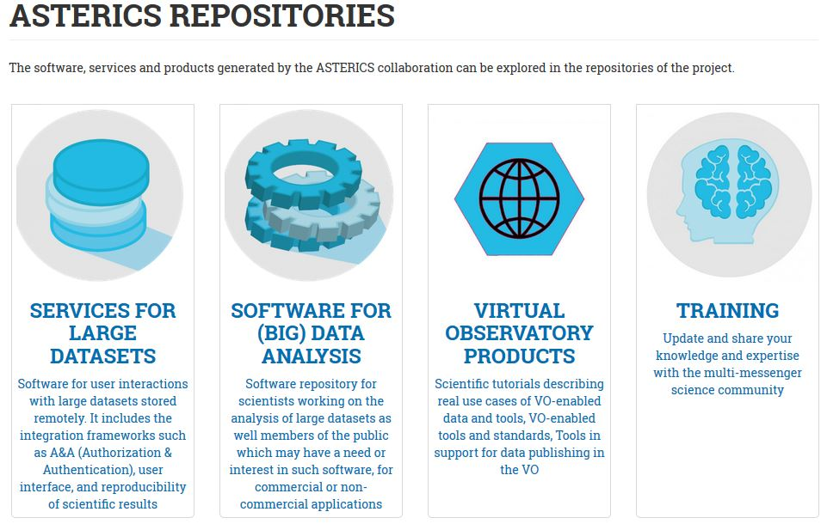
Figure 1: ASTERICS repositories, to be kept up to date after the project.

This chapter describes the work carried out during the reporting period (1 May 2018 -30 April 2019) in line with the Annex 1 to the Grant Agreement (Description of Action (DoA)).
In Section 1.1, a list of specific ASTERICS objectives is followed by a description of the progress towards the achievement of those objectives during the last 12 months of the project. There are some slight delays in closing the latest deliverables of the project, so we will report all results until we close this report for submission, during June 2019.

Objectives
The main objective of ASTERICS was to establish a single collaborative cluster of next generation ESFRI telescope facilities in the area of astronomy, astrophysics and astroparticle physics by identifying, addressing and solving key challenges of common interest, adopting cross-cutting solutions with mutual and wide-ranging benefit to all concerned.
ASTERICS facilitates the process of identifying areas of rapid technology development, where the adoption of a complementary and synergetic approach across the ESFRI projects can lead to significant added value in their operational phase. Moreover, as the ESFRI projects sharply focus on their own design requirements, ASTERICS looks towards enabling interoperability between the facilities, minimising fragmentation, encouraging cross-fertilisation, developing joint multi-wavelength/multi-messenger capabilities, and opening-up the next generation.
During the third year of the ASTERICS project, we concluded that the goal of the project, to bring astronomers and astroparticle physicists together and have them develop tools together and learn from each other where possible, was mostly achieved. We had broken the four silos (radio, optical, gamma-rays and neutrinos) and scientists and developers were now working together on the four topics in data (generation, integration, analysis), the Virtual Observatory, timing and scheduling, and citizen science (see Figure 2).

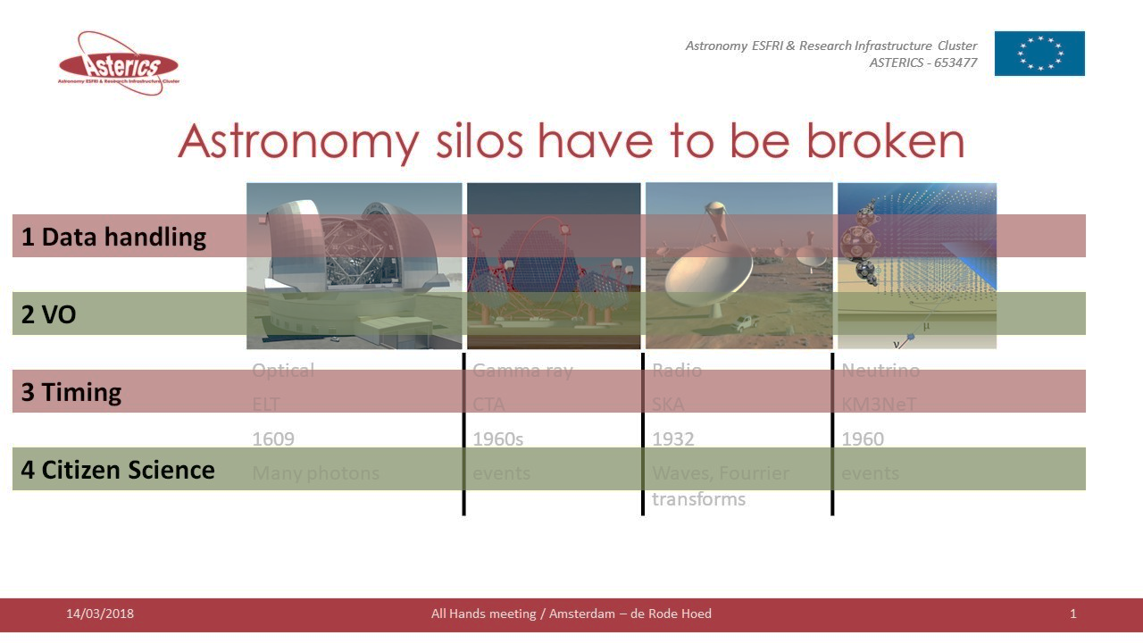
Figure 2. Astronomy silos within ASTERICS.
To avoid creating new silos, we successfully organized meetings to bring all persons working on ASTERICS subjects together to exchange results, successes, developments and questions and create what we called diagonal links through the collaboration.
Vertical were the original ‘messenger’ silos, horizontal the ASTERICS WPs and tasks. The diagonal links would create an optimal fabric for collaboration and continuing collaboration after the project (Figure 3).
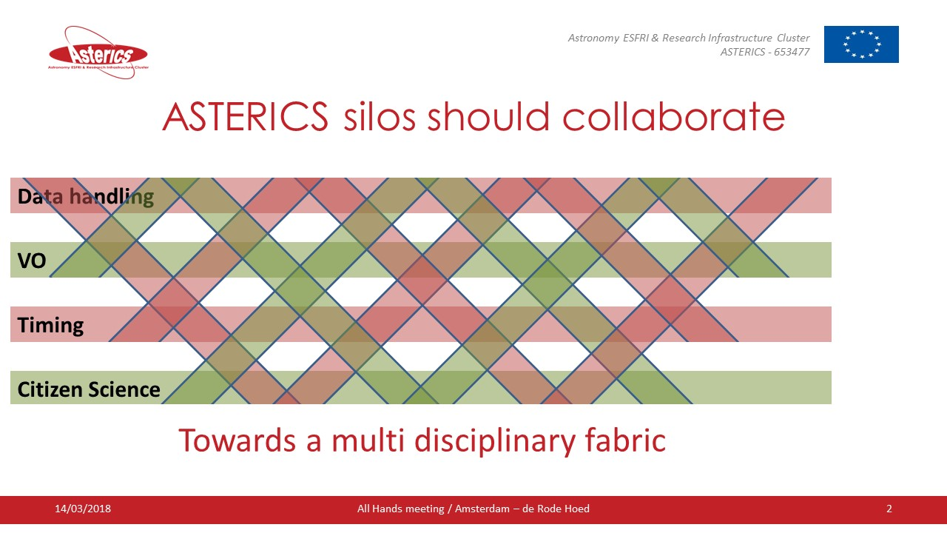
Figure 3. The diagonal links create an optimal fabric for collaboration and continuing collaboration after the project
Due to the high number of workshops and schools in the final year of the project and the Grand Event, it was not possible to fit another all-hands meeting. We did organise a DADI/OBELICS (WP3 WP4) A&A face-to-face meeting in January 2019.

To achieve the ASTERICS main goal, a set of objectives have been set. These are described in the DoA and reported below (italic text):

- Maximise software re-use and technology co-development for the robust, scalable and flexible handling and exploitation of the huge data streams and distributed petascale database systems associated with the ESFRI facilities - identifying best practice, defining open standards, design patterns and benchmarks, generating prototypes, constructing use-cases, and optimising frameworks and software libraries in an open innovation environment.
The OBELICS software repository (http://repository.asterics2020.eu/software) was released in 2018. It contains a collection of statistically robust and domain independent open source software libraries for data analysis and data mining on Peta-scale datasets. During the reporting period, these software and services were further updated and enhanced with addition of new software.

WP4 DADI contributes by providing building blocks from the Virtual Observatory framework of open standards and tools. These have been initially developed for enabling interoperability and are now more and more used by projects including in their data pipelines.

- Investigate and demonstrate data integration across the ESFRI facilities, using data mining tools and statistical (e.g. Bayesian) analysis techniques, introducing adaptable and evolving work management systems that will permit deployment on existing and future e-science infrastructures.
A repository of services (http://repository.asterics2020.eu) providing a framework for the analysis and integration of data for large-scale infrastructures was released under WP3 in 2018. These services were developed or evaluated under the OBELICS work package. The updated services concerned authentication and authorisation technologies for the astronomical data centres.

- Coordinate and harmonise the joint and efficient scheduling, operation and interoperability of the ESFRI facilities (and indeed other ground and space based telescopes) via a high-level policy forum and through technical developments such as innovative time synchronisation that enable multi-messenger astronomy via a rapid exchange and evaluation of VOEvent messages alerts, taking into account all necessary book-keeping logistics such as interchange formats, authorisation, prioritisation and identity methodology.
The Successful First ASTERICS Policy Forum in January 2018 was followed by a meeting on 19-20 November 2018 in Den Haag, NL, dedicated to finalising the report with recommendations. Representatives of the ESFRI facilities in ASTERICS participated to the meeting. The final report was presented to the scientists during the ASTERICS multi-messenger workshop in March 2019. The report will be published in the proceedings of the workshop. This paper summarizes the status, opportunities and some future policy initiatives relevant to future multi-wavelength/multi-messenger (MW/MM) astrophysics. This summary is considered timely given the ramp-up in facilities and widening exploration of physics across the electromagnetic spectrum and beyond.

At the ASTERICS Grand Event, the policy Forum results were shown to the larger group of scientists and developers and a final discussion on the findings was facilitated. It turns out that it continues to be difficult to find the correct owner of the process to make the items on the policy forum discussion list the high priority it needs to lead to solutions on a short time. Collaboration to achieve common goals is not highest on any one’s agenda. The involved groups are perfectly capable of solving their own problems, but when it comes to spending time and money on a common problem, one still expects the other party to take the initiative and pick up the work and bill first. We have shown in this project that picking up that bill for several items has helped the community a lot and brings multi-messenger astrophysics a lot further than it would have been without the ASTERICS project.

DADI collaborates with CLEOPATRA to gather requirements on VOEvent and works in the IVOA Time Domain Interest Group to update the standard if required.

Several deliverables on timing and alerting were completed in the final year of the project and will be summarized in the related WP sections.

- Adapt the VO framework and tools to the ESFRI project needs, gathering requirements from the community and making the data interoperable in a homogeneous environment, enabling discovery and re-usage by the entire astronomical community and accessibility via a set of common tools and standards.

The four kinds of complementary events organised by DADI contribute to this objective. The Technology Forums (one during the period) are devoted to the discussion of the partners’ relevant technological activities and are used to strengthen cooperation and collaboration, and to prepare European input to the International Virtual Observatory (IVOA) meetings - the IVOA develops the astronomical interoperability standards. The ESFRI Forums and Training Events (none during the period) are dedicated to gathering the ESFRI and pathfinder requirements and feedback. The European Data Provider Forums and Training Events (one during the period) extend the concept to all data providers, and allow us to check the general relevance of the VO developments. The yearly DADI Schools (one during the period) also gather science usage requirements and feedback on VO-enabled tools. In addition, specific meetings are organised as required to progress in the gathering of requirements and technological discussion.
Requirements and feedback drive the DADI technological activities on the development of the VO framework of standards and tools. These activities are performed in the context of the IVOA Working and Interest Groups, and the results are presented during the IVOA Interoperability meetings. The first priority of DADI, the definition and deployment of interoperability standards for multi-dimensional data, was completed with the adoption of the last relevant standard in May 2017. Feedback from implementation has been gathered since then. The second one, time domain data, has been actively pursued in DADI and in the IVOA, under the leadership of DADI staff with significant progress. Significant progress also on sky tessellation and Provenance standards.

- Adapt and optimise extremely large database systems to fulfil the requirements of the ASTERICS ESFRI projects. This requires the development of use cases, prototypes and benchmarks to demonstrate scalability and deployment on distributed non-homogeneous resources. Cooperation with the ESFRI pathfinders, computing centres, e-infrastructure providers and industry will be organised and managed to fulfil this objective.

The initial versions of the WP3 OBELICS benchmark reports were released in 2017 (D3.8, D3.9). These reports included numerous tests on data format, data storage and transfer, and data processing in an automated pipeline and in large databases. Tests were performed on innovative hardware with low power consumption. At the end of the reporting period, these benchmark reports were further updated and released as deliverables D3.18 and D3.19 with inclusion of new software and services developed by OBELICS members under D-INT and D-GEX task.

- Disseminate the results of ASTERICS to as wide an audience as possible, via the production of high quality outreach materials and direct engagement with all relevant stakeholders. Open-up the ESFRI facilities to the general public via a suite of Citizen Scientist Mass Participation Experiments (MPEs) that will capture the interest of the general public, especially the next generation of future engineers and scientists.

WP2 DECS has produced a set of promotional tools. In collaboration with WP1 the website has been renewed. It is the introductory point of ASTERICS for a wide range of audience, from the general public to stakeholders. An ASTERICS brochure and pull-up banners are more specific tools that helped to disseminate ASTERICS results during international events. A new version of the brochure highlighting a selection of results obtained in ASTERICS in the first three years of the project was finished, published and distributed in April 2018. The renewed website and brochure focus more on the topics related to ASTERICS and less on the work packages than the previous versions and are more adapted for exploitation of the results. Additionally, in December 2018 the training repository and gallery were added to the website at https://www.asterics2020.eu/asterics-repositories. The use of social media by means of Twitter, LinkedIn and a Facebook page has allowed the project an instantaneous interaction and feedback.

- Train and educate the community in the usage and implementation of the ASTERICS products (e.g. the VO framework and tools), and make ESFRI staff active participants in the use of new cross-domain Big Data software solutions, processor architectures and citizen science applications. Build capacity in the field, to train and develop the next generation of scientists and engineers that will be the future users of the ESFRI astronomy facilities.
Around data and software development (WP3) and VO (WP4) several well attended and appreciated schools and workshops were organised. The schools attracted many young researchers from outside the project partners. Participants advertised under colleagues, gave local courses on the topics, or returned to the schools as tutors and some tutors came back to teach again. This shows the success of the schools. Details are given per WP.
The third ASTERICS-OBELICS workshop dedicated a whole day programme to the application of machine learning in various astronomy ESFRI and world-class projects such as the Cherenkov Telescope Array (CTA), the Square Kilometre Array (SKA) as well as the Large Synoptic Survey Telescope (LSST). This day also featured applications of deep learning techniques within gravitational wave research in the context of the LIGO/VIRGO collaboration and High energy physics research at CERN.
Python-based tools are increasingly gaining acceptance and importance in astronomy. At the same time, the clear trend is towards interoperable and open data.
A five-day workshop addressing Python and open data for gamma-ray astronomy was organized at MPI for Nuclear Physics in Heidelberg, Germany, from 18-22 March 2019. The goal of this meeting was to discuss the status and prospects of python and other open source solutions for gamma-ray astronomy and related fields.
The third edition of the ASTERICS-OBELICS international school (8-12 April 2019 in Annecy, France) successfully served the programming needs of the astronomy and astroparticle physics community. The program of the school was devoted to project development for ESFRI and other world-class projects featuring theoretical and hands-on training on Python development as well as training in C/C++ coding for Python. This training event was not only beneficial for the early stage researchers but also the senior researchers to upgrade their programming skills.
In the DADI work package training and education was part of the complementary events, organised roughly each year during the project, as described above in objective 4, the ESFRI Forums and Training Events (none during the period), the European Data Provider Forums and Training Events (one during the period), the yearly DADI Schools (one during the period).

Explanation of the work carried out

WP1 Management
This work package establishes the ASTERICS Management Support Team (AMST), thus guarantees the smooth execution of all financial, administrative and reporting elements of the project. It also permits the AMST to exercise central control and oversight of the scientific and technical progress of the project, as measured by the successful receipt of deliverables and secured milestones.

- A high-level Policy Forum (involving the ESFRI projects and other large astronomy research infrastructures) has been established in order to coordinate and agree new models for joint time allocation, observing and data access/sharing, in addition to other more general policy matters of common interest. The Policy Forum report is described in more detail in Section • The EOSC initiative has many related topics with the ASTERICS activities. Therefore, the ASTERICS project manager presented the ASTERICS activities and plans at several EOSC events.
- Members from the management support team participated in the Third ASTERICS – OBELICS Workshop in October 2018, in Cambridge, had a special session on EOSC in Astronomy and Astrophysics.
- An inventory was made of existing collaborations in the project by asking feedback from the partners.
- The contacts with SMEs S[&]T, TriOpSys and Common Workflow Language (CWL) were transformed into short projects in the context of the Industrial Collaboration Call organised in WP3.
- The European Solar Telescope (EST) became a full partners in the project.
- There are continuing contacts with APPEC and ASTRONET. Both were represented in the Policy Forum and informal contacts were continued during other meetings and serendipitous encounters.
- The contact with H2020 projects EMBRIC, ENVRIplus, CORBEL, PARTHENOS, RISCAPE, SERISS and SINE2020 on dissemination activities was continued. There were irregular telecons to keep each other informed on activities.
- Contacts with EGI crystalized into two EOSC project collaborations.
- There were several contacts with the gravitational wave community, via email and meetings. We decide to strengthen the multi-messenger tools and communication through the ASTERICS activities. The working group for this activity gathered requirements and suggestions and wrote a proposal for a multi-messenger platform prototype with requested functionalities. This work was added to the ASTERICS project in Amendment-4, approved in March 2019. The group already started working in January. During their work on the project, it has become clear that multiple initiatives worldwide have started to facilitate multi-messenger astrophysics with on-line tools. At this moment, it is not clear which tools will mature in the coming years and where they will be hosted. In addition, the group noticed that there is no coordination in the development of tools, but that they are separate initiatives. The ASTERICS multi-messenger platform is a functional starting point and a good example of how different developments could come together to form an end-to-end process and where scientists could exchange information.
The platform is ready as a prototype. The plan I in the coming year to build a functional core platform. Since this is outside the ASTERICS project, new budget has to be found. We hope the start made with ASTERICS money show enough potential to fund the further development. Even important is the funding necessary to develop and maintain the fully collaborative platform. All steps and functionalities are described in deliverable report D5.16.
Events.

A final grand event was organised to show-case the results of the project and their relevance to the ESFRI telescopes and all other relevant stakeholders. More information about this final event can be found in Section 1.2.1.4 Events.

Management and administration
The management support team oversees smooth execution of the financial elements of the project by monitoring the partner’s expenses on a six-month cycle. This way we noticed early on that some partners started their activities slower than expected. This was addressed in the first and second periodic reviews. Partners increased the activity and in the previous cycle however it became clear that some of the partners would still be underspending. These partners have allowed allocating part of their budget to elsewhere in the project for new activities, travel and hiring people.
Therefore, two amendments were submitted.

Three activities during the last reporting period were not planned:
- An amendment was started to include Leibniz-Institut fuer Sonnenphysik (KIS) as a partner to represent the European Solar Telescope (EST),
- As a result of the call for industry collaboration, CNRS had arranged the contract with the SMEs. It turned out that, although it had worked previously, the execution of the call did not fulfil the tendering rules of both CNRS and ASTRON. Therefore, both partners’ legal and financial departments did not accept to create a contract with the SME. Therefore an amendment was started to include S[&]T as a partner instead of subcontractor. Additionally, the contract for the CWL industry project with CNRS was transferred to ASTRON and budget was moved accordingly from CNRS to ASTRON.
- The ASTERICS General Assembly approved in November 2018 the initiative to build a prototype multi-messenger platform. As a result of the recent developments in multi-messenger astrophysics and the GW detection people coming from different fields are starting to work together. In light of this new direction, a prototype was developed to facilitate collaborations between observatories and researchers, both for planned joint observations and observations in response to events such as gravitational wave detections.

There was one important and time-consuming financial issue. When organising a workshop for a selected group of participants, it is very convenient to have one partner cover all the costs. Most of the meetings supported by ASTERICS project funding were organised in that way. For the ASTERICS final event, we aimed for attracting many scientists and developers from outside the ASTERICS consortium. Therefore we could not support all the workshop costs from the project and decide to ask a conference fee from the participant. Of course, the project collaborators can then pay the fee from their project budget, as it is a project activity. If ASTRON would have hired a professional conference organiser, that would also collect the fees, this would be possible. We tried this, but we considered it too expensive for the project. Therefore, the conference fee was transferred to ASTRON, resulting in a transfer between partners.
Asking a fee to be paid in advance of the meeting at registration, requires the participant seriously think about the participation and probably even handling an internal request within their institutes for approval, following the existing authorisation lines. This makes the probability of the participant actually attending the meeting much higher and in case of a no-show, the financial burden is with the participant and not with the organiser. This is also true for participants from project partner institutes. With hindsight, we could have organised a registration option for partners, where the partner institute would authorize participation for their employees. For that we would have had to set up a new authorisation structure, not necessarily overlapping with the system put in place by the partner institutes. At the time we needed to decide on the website, we thought this was more difficult than to outsource the fee collection. To prevent transfers between partners, we reversed all payments from partners and deducted the required fee from the partners’ budget, to be settled in the final financial overview at the end of the project.
We still think that the whole process requires much more administration that a normal payment system, but that would involve payments between partners. We hope the EC financial team finds a solution for this in the near future.

In addition, the management support team keeps track of Deliverables and Milestones, lists of publications, dissemination etc. Some deliverables had a considerable delay. This was communicated with the Project Officer. We did not manage to submit all deliverables before the end of the project, but all were submitted before the end of the final report was due.
The work package leaders continued to have meetings (mostly teleconferences) every two months. The ASTERICS General Assembly (AGA) Chair is also invited to these meetings.

Governance
ASTERICS General Assembly
There were two ASTERICS General Assembly (AGA) meetings during Project Period 3:
- #6 - 26 November 2018
- #7 - 28 March 2019.
At these meetings, the AGA was informed by the coordinator and WP leaders about the project status and the AGA discussed activities and policies.
ASTERICS External Advisory Board
The ASTERICS External Advisory Board (AEAB) met for the third time during the AGA-6 in November 2018 and participated in the AGA. The AEAB presented their findings to the AGA. The AEAB was positive about the project achievements and recommend to the ASTERICS project team about their future role in the European Open Science Cloud and the H2020 project ESCAPE. The written report of the AEAB can be found in Annex 1, (Section 5.1).

      - Collaboration and Exploitation
The Collaboration and Exploitation plan were aimed at looking for new collaborations and promoting ASTERICS at meetings, events and with other stakeholders.
The following activities took place in the third reporting period:
- The EOSC initiative has many related topics with the ASTERICS activities. Therefore, the ASTERICS project manager presented the ASTERICS activities and plans at several EOSC events.
- Members from the management support team participated in the Third ASTERICS – OBELICS Workshop in October 2018, in Cambridge, had a special session on EOSC in Astronomy and Astrophysics.
- An inventory was made of existing collaborations in the project by asking feedback from the partners.
- The contacts with SMEs S[&]T, TriOpSys and Common Workflow Language (CWL) were transformed into short projects in the context of the Industrial Collaboration Call organised in WP3.
- The European Solar Telescope (EST) became a full partners in the project.
- There are continuing contacts with APPEC and ASTRONET. Both were represented in the Policy Forum and informal contacts were continued during other meetings and serendipitous encounters.
- The contact with H2020 projects EMBRIC, ENVRIplus, CORBEL, PARTHENOS, RISCAPE, SERISS and SINE2020 on dissemination activities was continued. There were irregular telecons to keep each other informed on activities.
- Contacts with EGI crystalized into two EOSC project collaborations.
- There were several contacts with the gravitational wave community, via email and meetings. We decide to strengthen the multi-messenger tools and communication through the ASTERICS activities. The working group for this activity gathered requirements and suggestions and wrote a proposal for a multi-messenger platform prototype with requested functionalities. This work was added to the ASTERICS project in Amendment-4, approved in March 2019. The group already started working in January. During their work on the project, it has become clear that multiple initiatives worldwide have started to facilitate multi-messenger astrophysics with on-line tools. At this moment, it is not clear which tools will mature in the coming years and where they will be hosted. In addition, the group noticed that there is no coordination in the development of tools, but that they are separate initiatives. The ASTERICS multi-messenger platform is a functional starting point and a good example of how different developments could come together to form an end-to-end process and where scientists could exchange information.
The platform is ready as a prototype. The plan I in the coming year to build a functional core platform. Since this is outside the ASTERICS project, new budget has to be found. We hope the start made with ASTERICS money show enough potential to fund the further development. Even important is the funding necessary to develop and maintain the fully collaborative platform. All steps and functionalities are described in deliverable report D5.16.

Events

Policy Forum
The Successful First ASTERICS Policy Forum in January 2018 was followed by a meeting on 19-20 November 2018 in Den Haag, NL, dedicated to finalising the report with recommendations. Representatives of the ESFRI facilities in ASTERICS participated to the meeting.
At the ASTERICS Grand Event in March 2019, the policy Forum results were shown to the larger group of scientists and developers and a final discussion on the findings was facilitated. The report will be published in the proceedings of the workshop. This paper summarizes the status, opportunities and some future policy initiatives relevant to future multi-wavelength/multi-messenger (MW/MM) astrophysics. This summary is considered timely given the ramp-up in facilities and widening exploration of physics across the electromagnetic spectrum and beyond.

It turns out that it continues to be difficult to find the correct owner of the process to make the items on the policy forum discussion list the high priority it needs to lead to solutions on a short time. Collaboration to achieve common goals is not highest on any one’s agenda. The involved groups are perfectly capable of solving their own problems, but when it comes to spending time and money on a common problem, one still expects the other party to take the initiative and pick up the work and bill first. We have shown in this project that picking up that bill for several items has helped the community a lot and has brought multi-messenger astrophysics a lot further than it would have been without the ASTERICS project.

The final report as published in the proceedings of the ASTERICS final event can be found in Annex 2 (Section 5.2) of this document.

Final ASTERICS Grand Event
The final grand event was setup as a symposium and was titled: The new era of multi-messenger astrophysics. It took place from 25 to 29 March 2019 in Groningen at the conference venue Martini Plaza. Due to competing events we scaled down the number of participants and reached 128 registrations and of those, over 100 participants on the first three days and 80 on the final day. The lower number on the last day was expected, as this was a dedicated workshop with discussion on multi-messenger challenges. The first three days presented more results both on science and technology.
At the symposium presented the project results and other relevant research. Project partners showed the results of the project and their relevance to the ESFRI telescopes and all other relevant stakeholders. The Policy Forum was also integrated in the programme. Presentation and proceedings of the symposium can be found on the website: http://multi-messenger.asterics2020.eu/. A full report of the event is available in Deliverable report D1.5.

WP2 DECS
The objective of WP2 DECS is to disseminate the results of ASTERICS to as wide an audience as possible, via the production of high-quality outreach materials and direct engagement with all relevant stakeholders. Open-up the ESFRI facilities to the general public vis a suite of Citizen Scientist Mass Participation Experiments (MPEs) that will capture the interest of the general public, especially the next generation of future scientist and engineers. The following products have been produced in this reporting period to contribute these objectives:
- ‘Euclid: Challenge the Machines’ mass participation experiment (see Section 1.2.2.1)
- ‘Muon Hunters 2.0: Return of the Ring’ mass participation experiment (see Section 1.2.2.1)
- ‘SuperWASP Variable Stars’ mass participation experiment (see Section 1.2.2.1)
- Funding the visit of Prof. Piotr Homola to The Open University (see Section 1.2.2.2)
- International Meetings (see Section 1.2.2.3)
- Quarterly Newsletters (see Section 1.2.2.4)
- Badged Open Course (see Section 1.2.2.5)
- Dallas Campbell Filming (see 1.2.6)
- Publications
The following deliverables have been successfully completed in this reporting period, following publications and inputs from all beneficiaries in WP2 DECS:
- D2.8 Online Mass Participation Experiment
- D2.9 Open access publications from Mass Participation Experiments

Mass Participation Experiments
The ‘Euclid: Challenge the Machines’ mass participation experiment aims to identify strong gravitational lensing events in simulated Euclid data and in Hubble Space Telescope data. As well as being available in the standard browser version this project is also a pioneer of the mobile device capabilities of the Zooniverse platform. The project has recently passed Beta testing and is now under review by the Zooniverse community before being fully released in the near future. The experiment can be accessed at
https://www.zooniverse.org/projects/hughdickinson/euclid-challenge-the-machines
or via the Zooniverse Mobile app
https://play.google.com/store/apps/details?id=com.zooniversemobile&hl=en_GB
where a review of the experiment can also be submitted.

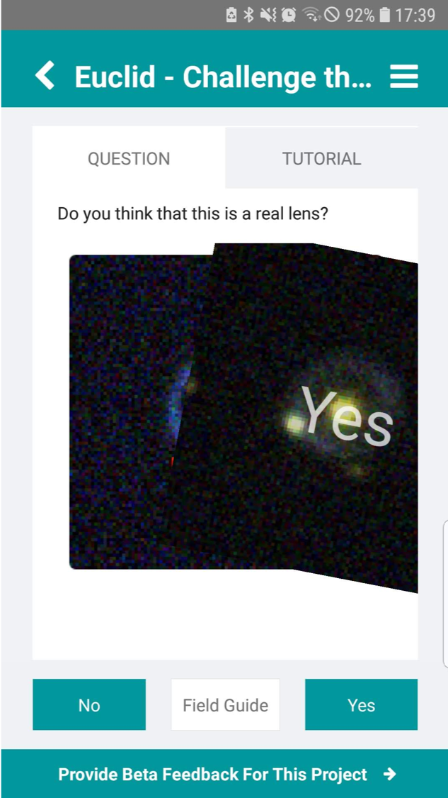
This represents one of the two experiments that originated, in part, from our ASTERICS citizen science workshop discussions (the other being the highly successful Muon Hunter experiment). The VERITAS team had been, and still are, particularly keen to launch new citizen science experiment in the run-up to the launch of the Cherenkov Telescope Array, therefore this reporting period has also seen the release of ‘Muon Hunters 2.0: Return of the Ring’.
Figure 4. Euclid: Challenge the Machines experiment on the Zooniverse mobile app
This project aims to identify gamma-ray signals in images taken by the VERITAS telescopes. But, in contrast to the first version of the Muon Hunters experiment, version 2.0 utilises a machine learning algorithm and the public are now needed to help analyse how successful this algorithm is at identifying gamma-ray rings in the data. The experiment can be accessed at https://www.zooniverse.org/projects/dwright04/muon-hunters-2-dot-0.
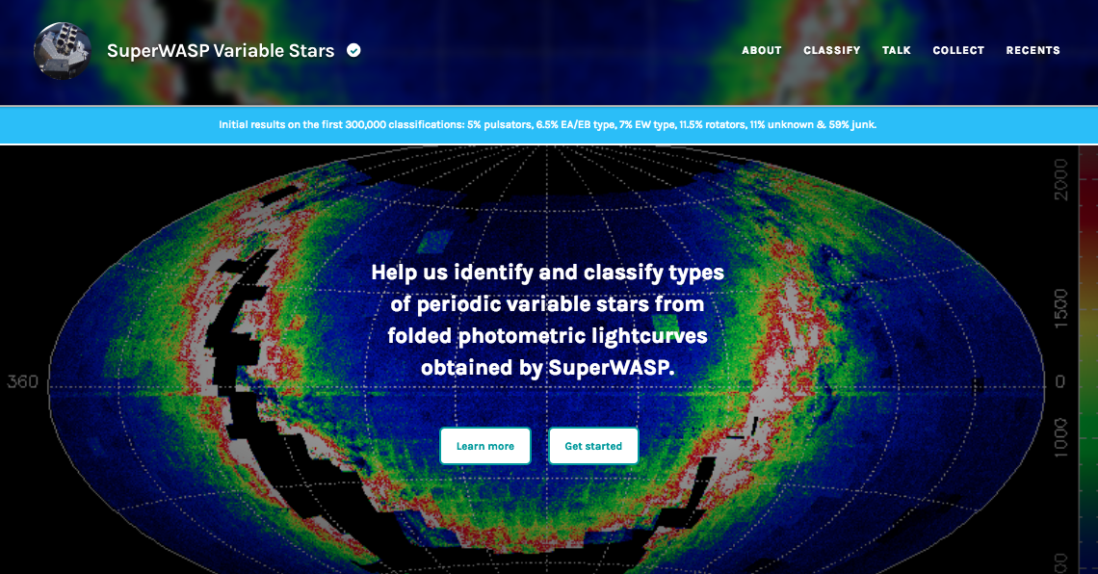
A third experiment released in this reporting period is the ‘SuperWASP Variable Stars’ experiment which aims to identify and classify the folded light curves as either eclipsing binary stars, pulsating stars, rotationally modulated stars, or simply junk. The SuperWASP instrument is the world's most successful ground-based survey for transiting exoplanets, but it’s light curves can also reveal many variable stars. With a data set of over 1.5 million possible periods in around 750,000 objects this experiment offers significant opportunities for new discoveries by volunteers. The experiment can be accessed at
Figure 5. SuperWASP experiment homepage on the Zooniverse website.
https://www.zooniverse.org/projects/ajnorton/superwasp-variable-stars.
Introductory printed material for all the ASTERICS citizen science projects aimed at the Young Stargazers of the Society for Popular Astronomy is being made, with a delivery date of the end of April; the material will also provide guidance for getting into astronomy and taking your interest further.

Prof. Piotr Homola Visit
For the period Monday 12th to Friday 16th November 2018 Professor Piotr Homola of the Institute of Nuclear Physics, Polish Academy of Sciences, Krakow, Poland made a working visit to The Open University (OU), Milton Keynes, UK. This visit was funded by ASTERICS for the purpose of maintaining the relationship between ASTERICS and CREDO, brainstorming future goals and exploring the prospects for long term collaboration. During this visit Prof. Homola was also granted visitor status by the OU for the period 12th November 2018 to 31st July 2019.
The visit was felt to be productive by both parties as a wide variety of potential deliverables were discussed with mutual benefit to ASTERICS and CREDO. These included:
- Website resources
- Educational resources
- Joint publications
- Joint grant proposals
- Expansion of CREDO public engagement activities across Europe
In addition, meetings were held with the OU philanthropic team and OpenSTEM Labs team with a view to acquiring further funding for the CREDO project beyond the end of ASTERICS and embedding a CREDO style detector into the publicly accessible, distance learning laboratory facilities offered by the OpenSTEM Labs http://stem.open.ac.uk/study/openstem-labs.

International Meetings
During this reporting period a wide variety of presentations and meetings have taken place in which ASTERICS DECS deliverables have been discussed and showcased:
- ASTERICS based Citizen Science opportunities were presented to colleagues at the Ethiopian Space Science and Technology Institute (http://etssti.org/) in August 2018.
- The core principals and power of citizen science were presented to the ‘School for Astroparticle Physics’ (https://indico.ecap.work/event/1/), Obertrubach-Bärnfels, Germany in October 2018.
- Citizen science-based opportunities were actively discussed with SPICA mission (http://www.spica-mission.org/) colleagues in London on 3-4 December 2018.
- ASTERICS (and ESCAPE) crowdsourcing opportunities for data mining were discussed at the MOONS Collaboration Meeting, Rome, Italy in January 2019.
- Meeting to discuss ASTERICS and ESCAPE citizen science with Chris Lintott (Zooniverse) and Christina Kourkoumelis in London on 18 March 2019.

Newsletters
The aspiration was for these newsletters to be issued approximately quarterly, with activity intended to be focussed on project phases with more to report. The member of staff responsible for the newsletter was on long term sick leave in 2018 so the newsletter was not published during the first six months of 2018, but this was not during a critical phase of the project so it is not obvious that a newsletter would have been published in any case. Nevertheless, in retrospect it would have been possible for the DECS lead to have asked staff at ASTRON to take responsibility for issuing a newsletter in this exceptional instance. Publications resumed upon their return with newsletters in August and December 2018.
The August 2018 newsletter reported on the ASTERICS All-Hands Meeting in Amsterdam, the Euclid: Challenge the Machines mass participation experiment, the first response of LOFAR to a transient astronomical event, upcoming events, a repository for open-source software established by the OBELICS work package and a report on the work of the CREDO collaboration. While the December 2018 newsletter reported on the SuperWASP Variable Stars mass participation experiment, key miles stones for the CREDO collaboration including ‘first light’ for the detector network and upcoming events.
These newsletters were opened by 65% and 72% of recipients respectively with approximately 10% of readers following links contained within them. With the project culminating in The New Era of Multi-Messenger Astrophysics conference during March 2019 (when the next quarterly newsletter would be due) it was decided not to publish any further newsletters after December 2018.

Badged Open Course
A Badged Open Course (BOC) hosted on the OU’s OpenLearn platform (https://www.open.edu/openlearn/) is scheduled for release on April 23rd to coincide with the University’s 50th Charter Day (https://50.open.ac.uk/).
This Astronomy with an Online Telescope course shows learners how to navigate the night sky, and introduces the wide variety of objects it contains. Learners develop a hands-on understanding of telescopic observations by accessing the OU’s own robotic telescope facility COAST (http://www.telescope.org/) sited on the island of Tenerife. Supported by their own measurements the course illustrates to learners (amongst other things) how we can learn more about the universe with multi-messenger astrophysics and how to use the Virtual Observatory tool Stellarium.

Figure 6 Trailer for the Badged Open Course ‘Astronomy with an Online Telescope’.

WP3 OBELICS
The OBELICS work package aims to enable interoperability and software re-use in data generation, integration, and analysis. The OBELICS work package is organized in the following four task groups to efficiently address these common challenges.

- Task 3.1 Management, user engagement and data dissemination (MAUD): This task concerns overall management of the work package, user engagement & data dissemination through thematic training events and general workshops.
- Task 3.2 Data generation & information extraction (D-GEX): This task aims at the first stage of the scientific data flow concerning data generation and information extraction.
- Task 3.3 Data systems integration: The task D-INT (3.3) is targeting the challenges in the data management of the large ESFRI infrastructures.
- Task 3.4 Data analysis /interpretation (D-ANA): This task addresses common challenges to assess the quality of Petascale datasets and execute automatic analysis to reduce their size by developing a collection of statistically robust and domain independent open source software libraries for data analysis and data mining on Peta-scale datasets. During the reporting period

Task 3.1 MAnagement, User engagement and data Dissemination (MAUD)
Between May 2018 and April 2019 MAUD organized a general workshop, a thematic workshop, and a thematic training event (school).
The third ASTERICS-OBELICS workshop (D3.16) took place at the Postdoc Centre-Eddington, University of Cambridge, United Kingdom, on 23-25 October 2018. It focused on dissemination of OBELICS achievements and plan for the final OBELICS deliverables considering the H2020-ASTERICS project conclusion in April 2019. In addition, this workshop explored novel use cases and approaches in machine learning in astronomy, astroparticle physics as well as particle physics. The workshop also discussed the current progress in the setting up of EOSC with presentations from various key players involved, such as the EOSCpilot and EOSC-hub projects. Unlike last edition, this year the workshop focused on more technical aspects and implementation roadmap of EOSC, which was of interests to the scientific community.

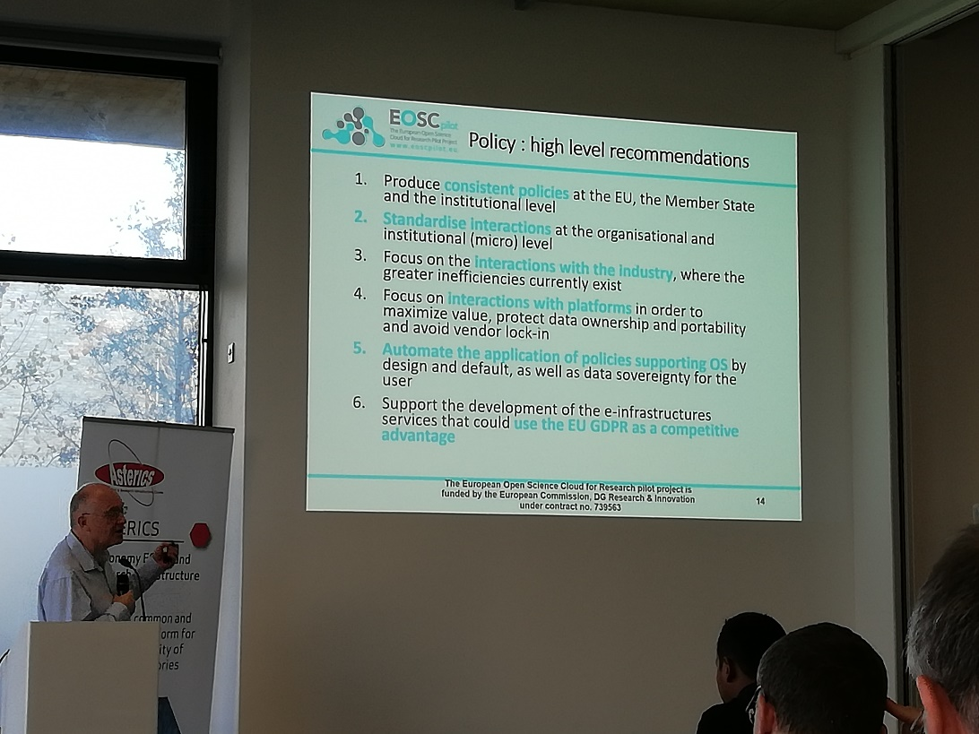
Figure 7. Brian Matthews from STFC presenting the European Open Science Cloud pilot at the third ASTERICS-OBELICS workshop.
The ASTERICS-OBELICS PyGamma workshop was organized at MPI for Nuclear Physics in Heidelberg, Germany, from 18 March to 22 March 2019. This workshop was specifically dedicated to introduce the participants to the new python based tools for the gamma ray astronomy applications. This five-day workshop was co-organized by MPI for Nuclear Physics in Heidelberg, Germany, and CNRS-LAPP. The workshop featured presentations on various python tools such as JetSeT, Gammapy, Astropy and 3ML.

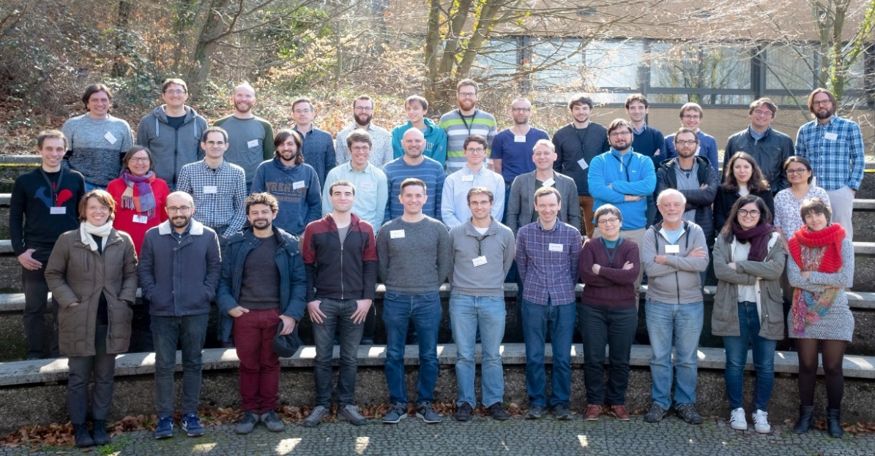
Figure 8. Participants of ASTERICS-OBELICS PyGamma workshop 2019.

The third ASTERICS-OBELICS International School on Advanced software programming for astrophysics and astroparticle physics was organized from 8-12 April 2019 in Annecy, France. This school was organized following the third ASTERICS-OBELICS workshop, where the need to organize another training event before the end of the project was discussed. This school was organised and hosted by the CNRS LAPP (Laboratoire d’Annecy de Physique de Particules) laboratory. This five-day training event brought together over 80 (59 students, 14 tutors and 17 organizers) PhD students, postdocs, senior researchers from the domain of astrophysics and astroparticle physics from renowned research institutes in Europe as well as Africa. The school provided theoretical and hands-on training to acquire efficient and fast computer programming techniques, as well as introduced participants to Machine Learning. Thanks to the tutors, the school successfully addressed the programming needs of the astrophysics community.
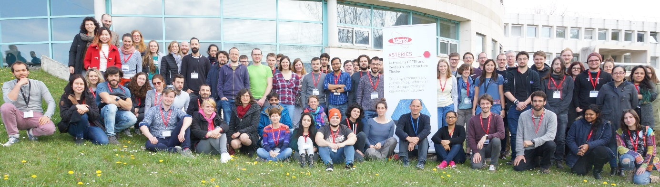
Figure 9. Participants of the third ASTERICS-OBELICS international school, 8-12 April 2019, Annecy, France.

During the reporting period, the following four industrial subcontracting projects were formalized and successfully completed.
- Astron data portal: This collaboration involved two Dutch industrial partners (TriOpSys and S[&]T) and ASTRON as the OBELICS partner. The ASTRON data portal provides the end-user with the possibility to discover, access and analyse Data Collections from several Instruments. Data Collections contain Data Products that can be in the form of raw data that is collected by Instruments and can also be derived Data Products.

- Modular data reduction on pipelines for astronomy data: This project had a Lithuanian industrial partner VIDE, a Dutch partner Pythonic.nl and two OBELICS partners INAF and ASTRON. This project focused on generating portable workflows for the scientific data exploitation of the ASTERICS partners ASTRON and INAF using common workflow language and containerisation, as well as documentation and support.

- Automated Solar Radio Bursts Detection through Machine Learning:
This project had a Dutch industrial partner S[&]T and ASTRON representing OBELICS. The goal of the project is to deliver a prototype implementation for a Machine Learning based pipeline that analyses a given input stream of radio spectrum data and provides an output prediction of Solar Radio Weather Events, in particular to determine the detection and classification of an ongoing Solar Radio Burst.

- Wavefier “A prototype for a real time Gravitational Wave transient signal classifier:
This project had an Italian industrial partner Trust-IT services and CNRS-LAPP was the OBELICS partner with scientific supervision from EGO. The goal of the project developed was to set up a prototype for a real-time pipeline for the detection of transient signals and their automatic classification. Moreover, the project also had the ultimate goal to test different software architecture solutions to prototype a scalable pipeline for big data and deep learning analysis in GW context. This subcontracting project was further extended with addition of more functionalities such as code engineering, real time stream data process, new ML algorithms for the data processing as well as an advanced dashboard.

Task 3.2 Data Generation & information Extraction (D-GEX)
The objective of this task is the first stage of the scientific data flow, that is, the Data GEneration and information eXtraction (D-GEX).

During the reporting period INAF partners carried out work aimed to deploy and make operational a high performance computation machine based on ARM based SoC (System on Chip) low power consumption architecture. This work has been done in synergy with the ExaNeSt H2020 project which aims at the design and development of an exascale ready supercomputer with a low energy consumption profile, but able to support the most demanding scientific and technical applications. This project will produce a prototype based on hybrid hardware (CPUs+accelerators, GPUs and FPGAs) and astrophysical codes are playing a fundamental role to validate the exascale platform. Preliminary work has been done to port on the heterogeneous platform a state-of-the-art N-body code (called ExaHiGPUs). The work done in the framework of the D-GEX task of the OBELICS work-package consists mainly in
- providing the deployment and operational support of the high performance and low power consumption computation machine built clustering a set of single board computers (Rockchip Firefly-RK3399);
- collaborating with the ExaNest software developers in the software testing phase;
- participating in designing a test bench and in performing a hardware benchmarking comparing the SoC components of the computation machine and a traditional Desktop with an embedded GPU. Tests have been carried on to quantitatively evaluate the impact of computation on the energy consumption on ARM SoC platforms, exploiting both CPU and embedded GPU. The energy-to-solutions and time-to-solutions using different ExaHiGPUs software configurations have been compared.

INAF (OAR) contribution to D-GEX was oriented in developing algorithms and in benchmarking innovative technical solutions for the data analysis software for the Cherenkov Telescope Array, the ESFRI project aimed to realize a ground-based observatory for gamma ray astronomy, and for its pathfinder ASTRI.
- In the contest of CTA and ASTRI projects, the INAF group has continued to develop data reduction and analysis algorithms to be run on a stream of data, also adopting innovative hardware like GPUs.
- FITS has been mainly adopted for the data format and algorithms are optimized on such a format. In particular engineering data and simulation have been formatted in this format.
- A good level of integration of the CTA data flow within the ASTRI CTA-precursor has been achieved. It includes also the handling of secondary data streams and meta-data (environmental and engineering data, temporary local archive, device control software and observation scheduling). Some solutions, largely adopted by the astronomical community like caldb (by NASA), have been finally integrated in the developed software.
- INAF (OAR) continued to test and benchmark low-power computer platforms (ARM+GPUs architectures e.g. Jetson TK-1 and the new Jetson TX-1) on the ASTRI data reduction and analysis software.

UCM partners reported the following activities under D-GEX task.
- The UCM group developed code to include the detailed simulation of the fluorescence emission in the CORSIKA code, and then used it to estimate the effect of fluorescence light in the observations carried out by IACTS (Imaging Atmospheric Cherenkov Telescopes).
- A contract was offered to study the formats proposed for the low-level Cherenkov Telescope Array data. It was awarded to the enterprise Quasar Science Resources that has compared different formats and developed a draft format based in the HDF5 system.

IFAE partners created a converter of MAGIC data to the DL3 format to validate the CTA DL3 format with real IACT data. This work is still ongoing with the development of a general pipeline to prepare a general release and the creation of a type of instrument response function (IRF) to be able to test the new analysis method implemented in the high level analysis software tool of CTA like the 3D analysis. As a member of the Gammapy team development, IFAE contributed to the tests of this format. IFAE also contributed to the first joint likelihood analysis of the Crab Nebulae using the data from H.E.S.S., MAGIC, VERITAS, FACT and Fermi, especially from the MAGIC side (with the previous DL3 converter for MAGIC data). All the data and scripts to reproduce the analysis will be made public.

In addition to the aforementioned activities, D-GEX members also produced the final version of Technology Benchmark Report, which was one of the deliverables (D3.18) of the work package. This deliverable discussed benchmarking performed on the data formats along with the other activities performed by D-GEX task members.

Task 3.3 Data systems INTegration (D-INT)
Data Integration is an important part of the data processing life. After its generation, and in order to be correctly analysed, data have to be stored in such a way to be easily and quickly retrieved, without alteration (preservation of its integrity). The task D-INT concentrates on data analysis, data storage, data preservation and data retrieval challenges of the large ESFRI astronomy infrastructures. In this section various activities reported by the OBELICS partners are described.
During the reporting period, CNRS-LAPP activities addressed investigations for the CTA raw data format. The CTA raw data format is not fixed. Several candidates were studied. In addition, CNRS-LAPP actively contributed to the development of several benchmarks to compare the raw data formats. They developed one of the candidates, hipeDATA, that allows very high-performance analysis.

INAF-OATs Trieste organized a two-day face-to-face meeting on 29-30 January 2019, with participation of members of WP3-OBELICS as well as WP4 DADI to address the following topics:
- Authentication & Authorisation (A&A)
- Single Sign-On
- Group Authorisation/Group Management systems
- Workflow development
- their relation with the development/upgrade within IVOA standards
The A&A meeting aim was to have a set of experts and interested parties discussing various aspects of the authentication and authorization mechanisms with respect to data and service providing and client access and consuming of the latter in the domain of astronomy and its interoperable framework.
The outcomes of the meeting included:
- networking different actors (data/service providers, VO experts, federated authentication experts, identity providers and managers, A&A consumers including both web based and programmatic UI developers)
- solving specific A&A description in the VO framework (e.g. for the TAP protocol)
- identifying pathways to improve credential delegation and its usage
- expressing advantages and drawbacks in hiding data and resources behind authentication layers
- evaluating the risks of having commercial resource vendors provide outsourcing for tasks that, until now, most research infrastructures provide by themselves

IFAE partners were involved in the creation, discussions and development of the open high-level data format specifications of CTA. This effort was intended to define a common format for the current generation of IACTs (and, ideally, other ESFRI Observatories). IFAE was also involved in the conversion of MAGIC data to this format that allows to improve it and try to define its limitation. IFAE also contributed in the development of Gammapy. The future CTA data portal will be based on the standard VO protocol that will allow to do fast query on the DL3 data and to deliver a high-level analysis procedure base on tools as Gammapy to analyse those data. The participation of IFAE to the first joint spectral analysis of the CrabNebula with H.E.S.S., MAGIC, VERITAS, FACT and Fermi data is the first step towards reproducibility and interoperability of multi-wavelength and multi-messenger analysis.

UCM activities were focused on a common format for high-level VHE Gamma ray observatories (the so called DL3). On this, basis packages as Gammapy (http://gammapy.org) are being developed, which are open code and are able to process and combine data from different observatories. This allows to share the code and improve the reproducibility of the results. Gammapy is also a candidate for the science tools of the Cherenkov Telescope Array.

In addition to aforementioned activities, D-INT members also produced the final version of Technology Benchmark Report, which was one of the deliverables (D3.19) of the work package. The deliverable provides description of nine data integration technologies developed by the OBELICS members and the details on the benchmarking results on each of the technologies.

Task 3.4 Data ANAlysis /interpretation (D-ANA):
The task 3.4 (D-ANA) addresses common challenge to assess the quality of Petascale datasets and execute automatic analysis to reduce their size by developing a collection of statistically robust and domain independent open source software libraries for data analysis and data mining on Peta-scale datasets. During the reporting period, task members also put together a software repository dedicated to workflow management services (D3.20). This repository is available on http://repository.asterics2020.eu/software.

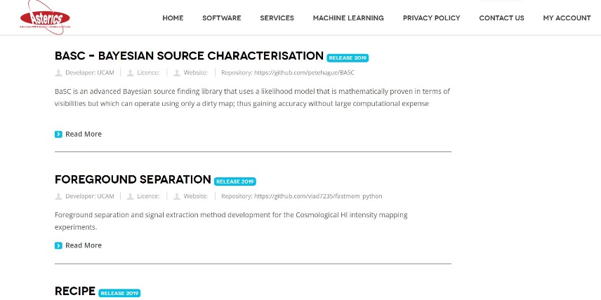
Figure 10: OBELICS software repository.

In addition to the repository, OBELICS partners have reported the following activities during the reporting period.

CNRS-LAPP reported investigation of deep learning applied to the Cherenkov Telescope Array. This work was carried out under the GammaLearner subcontracting project in collaboration with Orobix, an Italian SME. The activities included
- Efforts to understand better and improve the results obtained for single-telescope reconstruction.
- Investigation of the influence of the cleaning on the reconstruction performances.
- Production of reference curves with a standard analysis pipeline for single-telescope reconstruction.

INAF OACT had devoted the activities on the upgrade, consolidation, and maintenance and user support of the following two software:

- CTA - Authentication and Authorization Infrastructure API (INAF CTA AAI API): This API interfaces with the Attribute Authority of the INAF CTA Authentication and Authorization Infrastructure and exposes its entire business logic.
- CTA - Workflow Management System API (INAF CTA-WMS API): This API interfaces with the WMS of the INAF CTA science gateway and it is implemented through web services, which exposes the whole life cycle of the workflow management through SOAP and REST APIs.

The INAF CTA-WMS API has been extended to provide interfaces for interactive and high demanding User Interfaces (apart from the web portal access) enabling access to cloud resources. The API has been tested on the EGI FedCloud infrastructure, robot certificates are deployed on a Token Server provided by EGI and an access token is used to implement sessions among different requests.
Within the IA2 data centre, INAF OATs members studied the Common Workflow Language (CWL), since it is a specification for describing workflows in a way that makes them portable and scalable across a variety of software and hardware environments, including workstations, cluster, cloud infrastructure, and high performance computing environments.

The conclusions on CWL for astronomical tasks are:
- since CWL is a standard, it can provide an high level of interoperability between WMS and portability across different hardware environments
- CWL’s wide flexibility in workflow description makes it suitable for diverse kinds of workflows
- CWL supports natively Docker, which makes it appealing in the cloud paradigm
(we did not test this feature, but it is a future planned activity)
- CWL is excellent for jobs that must be run periodically, like ExoMerCat that needs to be run at least weekly

CNRS-APC implemented a proof-of-concept single-detector low-latency classifier for astrophysical signals (inspiral and mergers of binary black holes) and local detector artifacts (glitches) based on deep learning, using minimally-processed data (time series). The algorithm of choice is a 1D convolutional deep neural network. Implementation is done using the TensorFlow library [https://www.tensorflow.org] with a high-level neural network API [https://keras.io].
During the reporting period, JIVE worked on updating the CASA Jupyter kernel to the latest CASA releases (CASA 5.3, CASA 5.4.1). New docker & singularity images have been made available and the relevant code has been made available on GitHub and on the OBELICS software repository.
In addition to this update, JIVE has integrated “Recipe” into the CASA Jupyter kernel. This means that when changing and re-executing a Jupyter notebook that uses CASA tasks, only the cells that use outputs (as input) that have changed will be recomputed. This feature is available on a branch in the GitHub repository. Recipe was developed within the D-ANA task.

INFN has continued development of the ROAst and CORELib projects while restarting the pLISA project. These developments are available on the OBELICS software repository. Major improvements during the reporting period include final implementation of precise Sun and Moon motion and ability to produce graphs with Right Ascension in different conventions. The software underwent code review and quality improvement and was incorporated in the Aanet analysis framework used by the KM3NeT Collaboration. In the future, it is planned to propose ROAst as a standard package for ROOT or derivative analysis frameworks.
The CORELib update included designing the simulation jobs for the CORSIKA 7.5000 framework, managing a large production over thousands of computation nodes on the GRID, checking data quality and writing code to cast the output in a shape that enhances and simplifies data access and usage, in particular splitting the particles produced in different categories. In the near future, simulation of Cherenkov radiation is planned also for heavy nuclei-induced events. Contacts are ongoing to involve a larger community from several ESFRIs in joint efforts. Not only this version of CORELib will stay as a reference production, but it is also promoting cross-fertilization and cooperation among researchers with different interests and cultural background.
The evolution of pLISA is only at the beginning and a massive evolution is planned for the future, well beyond the end of ASTERICS. The first results were obtained by single GPU boards (NVidia GTX 1080Ti), but more powerful boards (NVidia RTX 2080Ti) and small farms are being set up, while the capabilities of the networks are being refined and methods are being developed to model also higher-order effects such as detector deformation, inefficiency and noise.
CEA partners reported the developments for general tools for wavelet cleaning and the analysis chain prototype in the context of the Cherenkov telescope array. These developments included reducing the number of scales in the wavelet cleaning at the minimum, i.e. two scales: the first scale correspond to the uncorrelated background charge (one pixel); the second scale (2 pixels) concentrates most of the shower signal. This choice led to a spectacular simplification of the optimization process. The analysis was done first on the large size telescope (LST) cameras, and shows that wavelet cleaning improves sensibly the direction estimate in each image (at the level of 0.5 to 1 degree at low and medium image charge).
In a second step, the information contained in the residual of the 2-scale wavelet decomposition was used in order to improve the shower charge recovery. The method consists in correcting the charge obtained in the first step with the residual pixel charge for the positions of the pixels kept in the second scale. This led to a much better charge collection than the reference image cleaning, with a charge resolution close to a normal (Gauss) distribution.
CEA has reported that the main objective has been reached, and in particular, they have shown that the wavelet algorithm used in “classical” astronomy can benefit to the Cherenkov astronomy through the cleaning of the atmospheric shower images. Their preliminary results show that several improvements are still possible and they will be investigated. The analysis should be performed not only on the LST sub-array, but also on both Northern and Southern full CTA arrays.
UCAM partners reported foreground separation and signal extraction method development for the Cosmological HI intensity mapping experiments during the reporting period. A redshifted signal of the neutral hydrogen from the Epoch of Reionization (EoR) should be detectable at the low frequencies 50 – 200 MHz. This signal is very weak having an amplitude of the tens of millikelvins, mK. The main challenge was to develop a technique to extract the cosmological HI signal in the presence of the strong and varying Galactic foregrounds like a synchrotron and a free-free emission. Maximum Entropy Method in spectral domain was used to perform a foreground separation and signal extraction using the simulated low-frequency data. Several optimization solutions were tested including the SciPy and PyTorch.
In addition, UCAM partners have also reported developments on Bayesian Source Discrimination in Radio Interferometry. The software is now in a useable form, publicly available on the OBELICS software repository. They have also published an article (Hague et al. 2019) that outlines the results of the tests performed, and confirms that the software is superior at source discrimination tasks to the usual pathway for radio astronomy of CLEAN/SExtractor and approaches the mathematically optimal resolution limit. UCAM partners were able to calculate the optimal performance for a constrained task (discriminating between two nearby points) and then construct appropriate testing sets. The design of the experiment was critical to confirming that BaSC did indeed work as expected.
S[&]T was added as a partner in the last month of the project, just for financial reasons. They were active in one of the industrial collaboration projects. Their activity in the project has been described in section 1.2.3.1 under item 3 (Automated Solar Radio Bursts Detection through Machine Learning:).

WP4 DADI
ASTERICS WP4 DADI objectives are to make the ESFRI and pathfinder project data available for discovery and usage by the whole astronomical community, interoperable in a homogeneous international framework, and accessible with a set of common tools. More specifically:
- Task 4.1, led by INAF and UHEI (Section 1.2.4.1)
Train and support ESFRI project staff in the usage and implementation of the Virtual Observatory (VO) framework and tools, and make them active participants in the development of the VO framework definition and updates, thus contributing to relevance and sustainability of the framework.
- Task 4.2, led by CNRS/UMR 7550-CDS and INTA (Section 1.2.4.2)
Train and support the wider astronomical community in scientific use of the framework, in particular for pathfinder data, and gather their requirements and feedback.
- Task 4.3, led by CNRS/UMR 7550-CDS and UEDIN (Section 1.2.4.3)
Adapt the VO framework and tools to the ESFRI project needs, and make sure European astronomers remain lead actors in the International Virtual Observatory Alliance (IVOA), influencing it in the interest of the European infrastructures and the European scientific community.
All DADI deliverables but one during the second reporting period, and all but two during the whole project, have been workshops of different kinds, which play a complementary role and are interconnected. Each task held one workshop during the reporting period. Each workshop is used to identify progress in the different activities, to share good practices, to foster collaboration between DADI partners and to prepare for the next meetings, including the IVOA ones. All along the project the meetings have been held at or close to the scheduled date, or several months before for the two European Data provider Forum and Training Events (D4.6 in June 2016 instead of November 2016, D4.13 in June 2018 instead of January 2019). Several months are needed after a workshop to prepare the “text deliverable” submitted to the Project Portal.
The two other deliverables were the mid-term and final versions of the Repository of WP4 products, D4.8 and D4.15, delivered respectively in April 2017 and May 2019.
DADI Milestones have been “Progress and Priorities” at the IVOA Interoperability meetings, which are held twice a year. Other important meetings are the yearly Astronomical Data Analysis Software and Systems (ADASS) conferences, which are held once a year back-to-back with the “Northern Fall” IVOA meetings, and the Plenary Meetings of the Research Data Alliance (RDA).
The meeting websites are linked from DADI wiki page, which also provides a link to the Repository of WP4 products.

Task 4.1: Training and support of ESFRI staff, and gathering their feedback and requirements
The Second European Data Provider Forum and Training Event (D4.13) was organised by UHEI in Heidelberg on 26 & 27 June 2018. The meeting was originally scheduled on Month 45 (January 2019), three months before the end of the project. As one of the aims of these meetings was to gather requirements and feedback from data providers, it was decided that it was more appropriate to organise it earlier so that the data provider input could be fully taken into account in the project activities.

The meeting, the second of its kind, was aimed at maintaining close contact between the European VO teams and the European data providers. This includes the facilities that are partners in the project (which also had two dedicated ESFRI Forums and Training Events organised during previous periods), and also the wider community of astronomy data providers. The meeting focused on a number of challenges and solutions in astronomical data publishing. It once again fulfilled the aim: data providers presented their specific requirements, use cases, and solutions, documenting the success of existing VO technologies, VO developments instigated by ASTERICS WP4, and new challenges for the use of the VO. Conversely, the VO community reached out to the data providers with discussions of new VO standards that are currently being developed or deployed, especially those corresponding to requirements previously identified within WP4.

Taking into account feedback from previous meetings, the afternoon before the meeting was dedicated to an introduction of key concepts of the VO for newcomers. A full day of consulting with VO specialists was held on the day after the meeting.

Task 4.2: Training and support of the wider astronomical community and gathering their feedback and requirements
The last annual DADI School was held during the period: the Fourth ASTERICS DADI European School (D4.12), organised by CNRS/CDS 20-22 November 2018 in Strasbourg.

The School followed the well established and proven format of having a short introduction about ASTERICS and the Virtual Observatory, followed by tutorials from VO experts on VO-enabled tools and services making use of real life science cases with hands-on exercises. Participants also had the opportunity to develop their own science cases. As usual, the School was targeted towards early career astronomers, but this time a handful of data stewards were also allowed to attend and this lead to very positive interactions.

The School was a success, with a great atmosphere favouring a lot of exchanges and discussions. The two goals of the School were fully achieved: expose early-career European astronomers to VO tools and services so that they can efficiently use them for their own research, and gather feedback and requirements from the participants, taking advantage of the intense and diverse usage. One can note for instance the strong interest of the participants for scripting capabilities, using Python and Jupyter Notebooks, which is well in line with requirements already identified in other venues, and the subject of developments in DADI.

The tutorials used in the School were updated to account for the latest advances in tool development and data releases of publicly available data. Feedback from participants in previous VO Schools helped to design useful, accessible, manageable but nevertheless challenging tutorials. One highlight was a tutorial allowing participants to explore the spatial location of gravitational wave events with the help of virtual reality, proposed and tutored by VIRGO/EGO/ET staff. The tutorials are available in the Repository of WP4 products (D4.15, see below) and in the sustainable Euro-VO website.

Task 4.3: Adaptation of the VO framework and tools to the ESFRI project needs, and impact in the IVOA
One deliverable workshop was held during the period: the Fifth ASTERICS DADI Technology Forum (D4.14), which was organised by CNRS/CDS 26-28 February 2019 in Strasbourg. It was accompanied by three co-located meetings:
- Preliminary meeting: EST and the VO, 26 February morning
- Extra event: Radio Astronomy and the VO, 28 February afternoon
- Project meeting: Multi-messenger Platform, 28 February afternoon
Like the preceding Technology Forums, the Fifth ASTERICS DADI Technology Forum was a highly productive event, which enabled in-depth technical discussion of many developments performed by the DADI teams. The meeting was organised with the well-established structure of formal presentations complemented by informal working ‘hack-a-thon’ discussions, which as usual was effective for the exchange of information and enabling lively discussion. Two of the ‘formal’ sessions focused on the current priorities of time domain and provenance. The third session included a discussion of the feedback from implementations of the multi-dimensional standards (which have been developed as one of the DADI priorities with key input from the DADI teams), an overview of the IVOA data modelling activities, a presentation of the European Solar Telescope, and a description of modular access to datasets using VO standards (which is a strong requirement from users with the fast development of Python usage in particular as explained). The fourth session was devoted to report from the Hack-a-thons, a retrospective of the Technology Forums and a presentation from the DADI lead which put the series of Technology Forums into perspective by recalling the history of the Virtual Observatory development and of the European projects which supported it, and discussed DADI impact, highlights and legacy, identifying how various of these activities are now in transition to the new ESCAPE project.

The meeting allowed us to establish DADI results and legacy, which have been presented at the ASTERICS Final Event, The New Era of Multi-messenger Astrophysics conference, which was held in Groningen 25-29 March 2019. The discussions also prepared the ASTERICS team for their participation in the May 2019 IVOA meeting, which will be held in Paris after the end of the project. The results and legacies of ASTERICS DADI will also be used by the WP4 of the ESCAPE Cluster, CEVO – Connecting ESFRI projects to the EOSC through the Virtual Observatory, which includes a task on FAIRisation of ESFRI data.

As usual, specific meetings were organised as required, with four meetings during the period (Table 1).
1 | Strasbourg Time Series Data Model Meeting | Strasbourg, 17-20 July 2018
2 | Provenance Days | Paris, 29-30 August 2018
3 | Exo-Planetary Data Model Meeting | Padova, 20-21 September 2018
4 | DADI/OBELICS A&A face-to-face meeting | Trieste, 29-30 January 2019
Table 1. DADI specific meetings relevant to technological activities held between the Fourth and Fifth Technology Forums.
The first one, in which the chair (M. Cresitello-Dittmar, CfA) and vice-chair (L. Michel, Strasbourg Observatory) of the IVOA Data Model Work Group participated, was instrumental for enabling progress in the definition of the IVOA Data Model for Time Series, one of the DADI priorities. The Provenance Days was the 7th of a series of meetings held since the beginning of the ASTERICS project to gather the main participants in the definition of the IVOA Provenance Data Model. The Exo-Planetary Data Model meeting was a follow-up of discussions with the GASP project to gather their requirements on Time Series. The DADI/OBELICS A&A meeting is a good example of cross-WG collaboration, on the common theme of authentication and authorisation, which is a need for many ESFRIs.

DADI staff also participated in the ASTERICS/OBELICS PyGamma19 - Python and open data for gamma-ray astronomy.

IVOA and ADASS meetings during the period
Two IVOA meetings were held during the period, in Victoria (Canada), 27 May – 1 June 2018, and College Park, MD, USA, 8-10 November 2018, back-to-back with the ADASS XXVIII Conference (11-15 November 2018). Progress and Priorities at these IVOA meetings are ASTERICS Milestones 24 and 27 respectively. They are summarised in the Milestone texts provided to the Project Portal. The talks presented by staff working in Europe are listed in the Repository of WP4 products.

DADI partners made significant contributions to the two meetings on activities relevant to many IVOA Working Groups and Interest Groups. Only a few highlights directly linked to DADI priorities will be discussed here. The activities pursued within the IVOA Time Domain Interest Group are of the utmost importance as an ASTERICS DADI priority, as well as a global IVOA priority. DADI partners played a major role in these sessions, which are led by the chair and co-chair, A. Nebot (CDS) and D. Morris (UEDIN) on the topics of Time Domain data serialization, Time Domain metadata and their practical use in real services, as well as on the overall approach to time domain data discovery, access and interoperability. The prior preparation via the two DADI Time Domain meetings (Strasbourg, 5-6 December 2017 and 17-20 July 2018) significantly facilitated progress. Provenance continues to be a major topic at IVOA, with numerous DADI contributions, in particular related to the CTA partner. In College Park M. Servillat (CNRS/LUTH) presented the status of the Provenance Data Model Proposed Recommendation, and other DADI related partners showed reference implementations. In the same meeting, the results of DADI efforts that build on HiPS and MOC (for access to survey data and to manage complex regions on the sky) were very visible in the Data Layer Access WG and Applications WG sessions, with the HiPStoFITS prototype, and access to HiPS and MOC via popular python tools, and also on-the-fly generation of subsets of data from large HiPS surveys. It is also notable that the IVOA began to organise a hack-a-thon session during the Victoria meeting, following the successful model of the DADI Technical Forum hack-a-thons.

The VO was very visible in many of the contributions to the ADASS XXVIII Conference, several of which were presented by persons involved in DADI. Two of the tutorials selected for ADASS XXVIII were focused on VO, the “All-sky astrophysics with HiPS and MOC” presented by S. Derriere (CDS), and “A comprehensive use case scenario of VO standards and protocols” by H. Heinl (UHEI) and D. Morris (UEDIN). An invited talk on “Data Challenges of the VO in Time Domain Astronomy” was presented by A. Nebot (CDS). Other contributions included “ProvTAP: A TAP service for providing IVOA provenance metadata” (F. Bonnarel, CDS). Presentations by ESA and ESO were also made about their data and archives. A number of posters were directly related to ASTERICS DADI, “Time in Aladin” (P. Fernique, CDS), “Getting ready for the fourth ASTERICS DADI virtual observatory school” (K. Lutz, CDS), “The IVOA Provenance Data Model” (M. Servillat, CNRS/LUTH). Another highlight of the posters was “The new science portal and the programmatic and VO interfaces of the ESO science archive” (A. Micol, ESO).

DADI also ensures liaison with the Research Data Alliance (RDA). Two RDA Plenary meetings were held during the period: the RDA Twelfth Plenary Meeting in Gaborone, Botswana, in the framework of the International Data Week (5-8 November 2018), very close in time to the College Park IVOA and ADASS meetings, and the RDA Thirtieth Plenary Meeting in Philadelphia, USA, 2-4 April 2019, just after the final ASTERICS Conference. DADI lead, F. Genova (CDS) continued to ensure the liaison, which was discussed in details in particular during the session of the IVOA Data Curation and Preservation Interest Group in Victoria. Links were also established between DADI and RDA activities on the topic of Provenance.

The collaboration between ASTERICS and IVOA was also exemplified by the presence of ASTERICS on the IVOA booth at the IAU General Assembly, Vienna, 20-31 August 2018. This provided a welcome exposure of ASTERICS activities to the global astronomical community. About 3000 people attended the conference. G. Iafrate (INAF) presented a talk on Virtual Observatory for Education at the General Assembly.

Repository of WP4 products
The final version of the Repository of WP4 products (D4.15) was delivered in May 2019. Its first version (mid-term delivery, D4.9) was delivered in April 2017, and it has been continuously maintained since then. DADI has several kind of “products”, including some which have been developed totally or partially with DADI support and some which are key components of the project with respect to the ESFRI and science needs. They can be broadly classified into several categories:
- Scientific tutorials describing real use cases of VO-enabled data and tools, prepared and updated in particular in the framework of the annual DADI Schools
- VO-enabled tools in support to the ESFRI and science needs identified by the project
- VO standards in support to the ESFRI needs identified by the project
- Tools in support to data publishing in the VO
- Other results of collaborative work
Presentations of DADI participants in the Interoperability meetings organised twice a year by the International Virtual Observatory Alliance IVOA can also be considered as DADI “products”. A list is provided in this repository.

The collection of DADI team members' contributions to the final ASTERICS event, The New Era of Multi-Messenger Astrophysics, is also one of the final products of DADI. The list is provided, with links to the slides or poster.

WP4 highlights and legacy

VO as a synergy field for the ESFRIs
As explained in Genova et al. (2015) and shown in Figure 11, collaboration between European teams to build the astronomical Virtual Observatory has been funded by the European Commission though a series of projects which, between 2001 and 2014, were centred on collaborative work to develop the Virtual Observatory interoperability framework in different European countries including, for some of the projects, the intergovernmental agencies ESA and/or ESO. The European Virtual Observatory collaboration currently is led by CNRS (France), and includes VO initiatives from Germany, Italy, Spain and UK respectively led by UHEI, INAF, INTA and UEDIN, working in close collaboration with ESA.
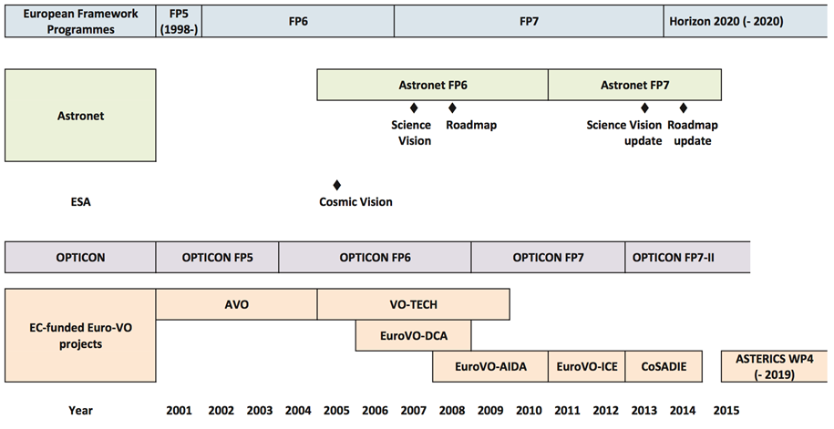
Figure 11. (from Genova et al., 2015): Timeline of the Euro-VO projects, related European structuring activities and strategy documents (time is rounded).
ASTERICS was a new stage for Euro-VO: the Virtual Observatory was one possible synergy of the cluster aim “to address cross-cutting synergies and common challenges shared by the Astronomy and Astroparticle ESFRI facilities”, with ASTERICS WP4 focused on Data Access, Discovery and Interoperability. At the end of the project, it is good to see that DADI has indeed enabled the initial Euro-VO partners to continue their collaborations, but it has also built collaborations between these VO-knowledgeable teams and teams from the ESFRI/”ESFRI-like” facilities and their pathfinders, both in astronomy and in astroparticle physics: the facilities/pathfinders involved in the project when it started were CTA, VIRGO/EGO/ET, KM3NeT and SKA, with ELT (ESO) associated to the project. The VO and facility teams worked together on brainstorming on requirements, and feedback on the VO standards and tools, in particular during the ESFRI and European Data Provider Forums and during the Technology Forums, and also through the facility team participation in VO-oriented technological activities. Several facility team members also became tutors in the DADI Schools. VIRGO/EGO/ET provided tutorials on gravitational waves, which were progressively adapted to take new discoveries into account, as explained.

Several facilities have been using VO standards and tools for their own needs, and they also became actors of the development of the VO. One can cite as examples of the impact of the VO for the ESFRI/”ESFRI-like” facilities:
- The inclusion of 5921 events from ANTARES, one of KM3NeT pathfinders, in the GAVO data centre, which enabled them to test the usefulness of the VO tools and is a test case for KM3NeT.
- The active participation of CTA in the definition of the IVOA model for Provenance, and the inclusion of the IVOA model in CTA data management system to define Provenance Configuration.
- The development of the GWSky () tool, based on VO standards and tools, to define the follow-up strategy of gravitational wave events.
- The implementation of VO standards in the new ESO programmatic interface (Romaniello et al, 2018), and the possible reuse of VO building blocks when relevant in the implementation strategy of the ESO Archive Services.
Building collaboration between astronomy and astroparticle in ASTERICS was particularly timely, with the first observations of gravitational waves, including one with electromagnetic counterparts, triggering a new era for multi-messenger astronomy during the project. VO tools were used to display the location of GW170814 in the press release (Figure 12).

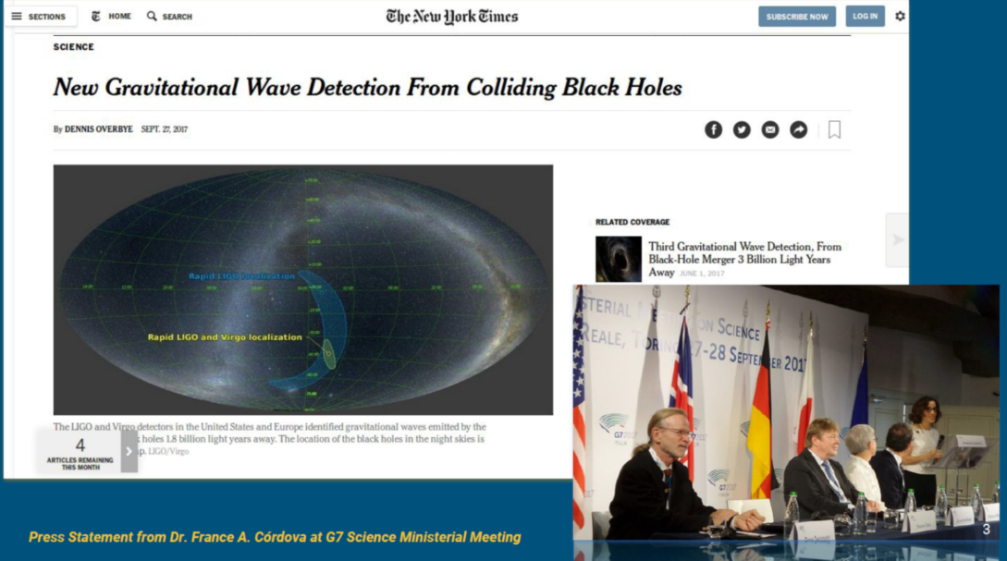
Figure 12. (from G. Greco’s presentation at the Second DADI ESFRI Forum & Training Event, December 2017).
The cross-disciplinary approach was extended to the solar observation domain during the course of the project – this was a recommendation of the ASTERICS Review, and also a logical new step because of the evolution of the ESFRI Roadmap. We began to liaise with EST, which was included in the ESFRI Roadmap in 2016, during the First European Data Provider and Training Event in June 2016. They joined ASTERICS as partner in 2018, and we have been able to hold preliminary discussions with them on how they could use or adapt the VO for their own needs during a dedicated event attached to the Fifth Technology Forum in February 2019.

VO as a community asset

The VO is enabling access to and interoperability between many observatory archives and widely used tools such as Aladin and TOPCAT. It has been successful at providing these functionalities seamlessly, so astronomers are often not aware of its role although they use it in their daily research work. This is why the Euro-VO projects have been eager to organise contacts with the community via Schools on the science usage of the VO, involving in particular early career researchers. In ASTERICS, the Schools were also used to inform ESFRI staff about the VO, and some of them became tutors in the next Schools afterward.

Students are encouraged to use the VO for their own research during the Schools, which is an excellent way to get feedback on VO tools from a variety of usages and topics. Scheduling the Schools on a yearly basis allowed us to prepare tutorials and to update them regularly, taking into account the evolution of VO tools, but also topical matters, such as gravitational waves or GAIA releases.

VO standards and tools

DADI activities have been instrumental to lead and support IVOA progress in key priority areas. This ensured that Europeans remain lead actors in IVOA, and that European interests are fully taken into account at the global level. DADI objective to adapt the VO framework to the ESFRI project needs helped the IVOA to take fully into account the requirements and feedback from large facilities. DADI staff was involved in gathering requirements and feedback on VO standards and tools. They led and participated in the discussion and authorship of standards, and prepared reference implementations to validate them.

Multi-dimensional and time domain data had already been identified as IVOA priorities, but DADI provided momentum and resources which led to significant progress. The set of standards finalized in May 2017 to deal with multi-dimensional data enable multi-D data discovery, link of resources, cutouts, as well as the management of HiPS, interfaces with applications, and virtual data generation. F. Bonnarel (CDS) was one of the authors of the three standards, and one of the two editors of two of them. M. Louys (CDS) is one of the editors of the related ObsCore standard, which ensures data discovery. For the Time Domain, A. Nebot (CDS) and D. Morris (UEDIN) took leadership and have been managing the discussions at the European and international levels. The interchange of time data will be fully ensured in the coming version of the VOTable standard, thanks to M. Demleitner (UHEI). In the domain of spatial sky coverage and sky tessellation, which quickly appeared as one ESFRI priority in DADI, P. Fernique (CDS) is the editor of the HiPs and MOC standards. M. Servillat (CNRS/LUTH – CTA) and G. Taffoni (INAF) are respectively the editor of the Provenance Data Model standard, and of the Sigle-Sign-On profile which describes the approved authentication mechanisms of IVOA. Linked to DADI activities in Task 4.2, H. Heinl (UHEI) was chosen as the co-chair of the Education Interest Group.

In general, the fact that several people involved in DADI were chair or vice-chair of IVOA Working Groups and Interest Groups also helped to maintain momentum. The history of the IVOA Group chairpersonship can be found in the IVOA History page. More information about the IVOA standards relevant to DADI activities can be found in the Repository of WP4 products. VO tools such as Aladin, GWSky, SPLAT-VO, STILTS, TOPCAT, and VOSA, also made significant progress during the course of ASTERICS.

Transitioning to ESCAPE

The next step for DADI collaboration is WP4 of the ESCAPE Cluster, Connecting ESFRI projects to EOSC through the Virtual Observatory framework (CEVO), led by M. Allen (CDS).

Legacies of ASTERICS DADI, in particular that ESFRIs have become both consumers and actors of the Virtual Observatory, the astronomy and astroparticle physics communities working hand in hand, the first contact taken with EST, leadership in and strong contributions to VO activities, schools and a collection of tutorials, a set of standards and the evolution of existing tools and provision of new tools (fulfilling the requirements of the ESFRIs and of the astronomical community), are all an excellent starting basis for CEVO. Task 4.2 of CEVO is about implementation of the FAIR principles for ESFRI data through the VO, which will build on DADI collaborations and results.

WP 5 Cleopatra
The activities in the work package CLEOPATRA aim at synergetic observing modes, and fast and reliable access to large data streams. These aspects are addressed in the following tasks:
- Development of technology for the enabling of long-haul and many-element time and frequency distribution over fibre connections. This has the potential to increase the efficiency and affordability of all radio astronomy facilities (SKA, LOFAR, VLBI). Such developments are also highly relevant for astroparticle facilities (CTA, KM3NeT) and can enable novel real-time multi messenger observations.
- Developing methods for relaying alerts that will signal transient event detections between the facilities and enable joint observing programmes. The focus will not just be on interchange formats but on scientific strategies and methods for joint observing.
- Further development of existing data streaming software, building on the success of previous e-VLBI projects, and providing tools for robust and efficient data dissemination for all facilities in the user domain, including ESO facilities such as ALMA and the E-ELT.
- Fostering the development of advanced scheduling algorithms, using AI approaches for optimal usage of the ESFRI facilities.
As the last reporting period progressed, efforts towards the final two demonstrations, planned for the end of the project, increased considerably. Some deliverables were delayed, for various reasons, but all were eventually delivered, albeit that the last few months became somewhat busy in this respect. Overall though, excellent progress was made throughout Cleopatra.

Task 5.1: Synchronization
This task is centred around the White Rabbit (WR) ethernet technology, with two quite distinct purposes. The first is upgrade WR to generic technology for deployment on long-haul public telecom networks, and to increase its frequency stability by three orders of magnitude in order to achieve the hydrogen maser level stability required by the SKA and other (commercial) applications. The second focuses on new calibration and characterisation tools for WR equipment, providing a faithful and accurate timing source to the many element detector arrays of the CTA and KM3NeT, while at the same time upgrading WR to 10Gbps data transport capability. J. Koelemeij, formerly of the VU, now OPNT, heads the first sub-package (5.1a), and D. Berge, formerly of FOM, now DESY, the second (5.1b).

- The work on Task 5.1a ramped up tremendously during this last year. OPNT, JIVE and SURFnet closely collaborated to install, calibrate and commission WR time and frequency transfer (TFT) equipment between the WSRT (near Zwiggelte) and the CAMRAS telescopes (Dwingeloo). This enabled a TFT link Zwiggelte-Groningen-Zwiggelte-Dwingeloo over the - live - SURFnet8 network.

The calibration and commissioning took place in two steps. The first step was included and described in deliverable D5.7: “Time transfer in SURFnet/LOFAR network & general design rules for network implementation”. On the round-trip link Zwiggelte – Groningen – Zwiggelte:

  - The time and frequency stability of the 2x67 km TFT link was measured (D5.7, Chapter 4.3). These measurements showed that the frequency stability of the 2x67 km TFT link is already within two times the frequency stability of a brand new hydrogen maser after an averaging time of 1000 seconds.
  - The link delay asymmetry caused by chromatic dispersion (CD) was calibrated, and these measurements were compared with CD data provided by SURFnet (D5.7, Chapter 4.4). Good agreement was found.
Once the link was in place, several important steps still had to be taken:

  - WR switches used on the complete link (169 km) were extensively calibrated, as well the WR switches used on a shorter (35 km) direct link between Zwiggelte and Dwingeloo.
  - Link delay asymmetry caused by chromatic dispersion (CD) on the short link was calibrated directly.
  - Using the calibrated short link as a reference, the long link was also delay calibrated. More extensive measurements were performed to compare the measured CD values with CD data provided by SURFnet.
  - The results of the measurements and calibrations of this link are documented in deliverable 5.14.
At the CAMRAS telescope, many different activities had to come together:
  - A VLBI formatter had to be implemented in GNU Radio, supporting multiple resolutions, a configurable number of channels and VDIF frames.
  - A real-time FPGA-based VLBI formatter was also designed and implemented in the RFNoC GNU Radio extension, however was not sufficiently debugged to be usable at the time of the demonstration.
  - Fiber had to be installed between the CAMRAS telescope and the ASTRON ICT room, including trenching, installing of a conduit, 270 m of fiber, splicing and testing. This was accomplished with the help of a large number of enthousiastic volunteers from the CAMRAS community.
  - A successful VLBI trial was conducted using the shorter (35 km) TFT link on March 8, 2019
  - A successful VLBI trial was conducted with the complete (169 km) TFT link on March 19, 2019
  - All the while, developments and tests with LOFAR were ongoing in parallel, transferring the H-maser signal from Groningen onwards to the LOFAR array located in the East of the Netherlands. After the end of the VLBI demonstration this connection will be dedicated to TFT to LOFAR, while CAMRAS will continue to make use of the 35 km connection.

All these activities and results were presented at the ASTERICS Grand Event at the end of March 2019, and are reported on in Deliverable D5.14: “Demonstration of VLBI synchronization via an optical telecom network”.

- Task 5.1b was focussed for a large part on wrapping up and documenting the work done in the previous years, but also on actual engineering, namely the re-design and improvement of existing WR hardware to support 10G Ethernet.

  - Deliverable D5.6: “Tools and methods for delay calibration before installation and in situ” describes the new calibration and characterization tools needed to calibrate hundreds of telescopes and thousands of optical modules.
  - For deliverable 5.3: “Qualification of WR components under (harsh) realistic conditions”, WR equipment was tested extensively in the TAIGA Gamma Observatory, located in the Tunka valley in Siberia. With ASTERICS funding a central GPS clock was purchased for the WR Grandmaster Switch. The test data was also extremely useful for debugging the Data Acquisition System (DAQ) on sub-ns time scales.
  - Finally, a large effort went into the implementation of a new solution capable of deploying WR technology for data and timing using 10G networks (D5.15, “Advanced algorithms and WR upgrade to 10Gb/s capacity”. Typically, because of the current 1Gb/s limitation, utilization of WR requires different timing and data networks, representing a significant increase of complexity and cost. With the new solution, using a modular and flexible architecture, an integrated and interoperable system has become available for infrastructures requiring high accuracy timing and high bandwidth data distribution on a single network.

Task 5.2: Multi messenger methods
Task 5.2 mainly concentrated on enabling a practical demo of automated triggering and following up of transient events.

- Apart from this, a study was completed into the synergies and challenges involved with the following up of transient events, using different instruments at different wavelengths (D5.11, “Scientific study of synergies of transient event observing”). Wavelength coverage, memoranda of understanding, scheduling and priorities are all issues that will have to be addressed, and solved, in the coming years, while the ESFRI facilities come online.
- Software components for multi-messenger event handling were written and deployed in LOFAR (LOFAR Responsive Telescope), cutting down the response time of the instrument to triggers to a mere few minutes (D5.10, “Software components for multi-messenger event handling”). Existing software was modified and added to for semi-automatically triggering the EVN network. The final deliverable (D5.13, “Pilot multi-messenger event handling”) describes a demo in which a (simulated) event, such as a gamma ray burst or a gravitational wave event, triggers a LOFAR observation within minutes, followed by a multi-phase centre observation by the EVN at very high resolution of a number of likely sources within the LOFAR field of view.
- Attached to the “Grand Event”, the final ASTERICS conference in Groningen, the Netherlands, a one-day workshop was held on the 29th of March 2019. This was a follow-up of the very successful workshop “Radio-gamma: transient alert mechanisms” organised by task 5.2 in Amsterdam on 26-28 September 2017. In spite of being on the last day of a four-day conference/workshop, many participants stayed on and took part in the discussions.

Task 5.3: Post-detection data streaming
Activities in Task 5.3 ramped down, as much of the work had been completed and the one deliverable delivered on time. However, results and insights gained from this task are feeding into the existing data transfer methods employed by JIVE and the EVN, and will be incorporated in new versions of the software.

Task 5.4: Scheduling of large astronomical infrastructures
Finally, Task 5.4 saw a flurry of activity towards the end of the period.
- Deliverable D5.9, “Report on scheduling algorithms and standard interfaces for cross-facility scheduling” was submitted, presenting an analysis of how to promote multi-messenger science through the building of collaborations, sharing observatory activities and schedules, and providing AI tools for efficient local and global scheduling. A scheduling framework called STARS was presented as well. This includes an abstraction of the scheduling problem and different algorithms (GA, MOEA, heuristics) that can be used at a range of facilities and for multi-observatory coordination.
- Deliverable D5.12, “Multi-facility scheduling simulation and performance analysis software demonstration”, makes quantitative estimates, through simulations, of how many simultaneous observations would be gained if it were possible to subsidiary schedule one facility with respect to other or optimize all the schedules simultaneously. The performance tests are applied to three different instruments with different characteristics, namely, a gamma-ray observatory (the Cherenkov Telescope Array - CTA), a radio large-scale array (the Square Kilometre array - SKA) and a 4.2m optical telescope (the William Herschel Telescope).
- Through some unexpected underspending in other parts of the project some extra funds became available. The task leader of Task 5.4 applied successfully for part of these funds, to be used to define and develop a multi-messenger platform. This is a software interface that will facilitate communication between instruments, the exchange of information and the scheduling of multi-wavelength multi-messenger events. The work on the platform was a collaboration between several ASTERICS work packages. The platform is built on foundations provided by the IVOA, in collaboration with partners in the DADI work package. Work on functionalities on triggering and alerting was provided by the CLEOPATRA work package and the outreach to new and outside partners was coordinated by WP1.

Impact (project as a whole)
For all Work Packages the information on impact remains relevant.

We achieved most of the impact we predicted in the Grant agreement, especially,
Expected impact:
- ASTERICS delivered added value to the ESFRI instruments by adding interoperability and interlinked scheduling and triggering.
- ASTERICS facilitated development of common services, open standards, data management solutions, ready-to-go software products, innovative and multi-use algorithms and advanced applications. The products generated by ASTERICS are openly and directly available to the ESFRI projects and the rest of the world.
- ASTERICS started the political process of ensuring routine interoperability between the ESFRI projects.
- ASTERICS made advances in data communication protocols and for enhanced time distribution methods, providing nanosecond accuracy for all the ESFRI detectors and instruments, irrespective of the astrophysical messenger they are built for.
- These technical developments will permit synergetic joint observing programmes between the ESFRI facilities and/or their pathfinders.
- While the telescopes all boast exceptional individual science cases, the impact of combining these forces together is likely to be substantial. It is difficult to quantify what the scientific impact might be numerically but the promise of an integrated multi-wavelength/multi-messenger distributed facility must be capable of generating profound scientific results, and very likely Nobel Prize winning research. The follow-up of the first GW observation of a binary Neutron star collision was assisted with the VO software GWSky.
- The Virtual Observatory (VO) framework made the available data and the number of users grow.
Innovation capacity & integration of new knowledge
- ASTERICS started to become a substantial multiplier, in terms of the facilities capacity, performance, scientific output and return on investment. ASTERICS activities on the new scientific challenges that require the kind of interoperable multi-messenger/multi-wavelength facilities ASTERICS aims for, have contributed to transform the astronomical landscape, creating new and interlinked neutrino and gravitational wave observatories, dependent on other electromagnetic counterparts to help elucidate the nature of these phenomena.
- ASTERICS also supports Competitive Industries in Europe, as an early adopter and indeed developer of the technologies and methodologies required to deal with a real-time data challenge that is extreme in terms of all major Big Data characteristics – Volume, Velocity, Variety and Veracity – the 3 (or 4) Vs. Similarly, ASTERICS also aims to advance the state-of-the-art in areas such as precision location positioning, wide area network synchronisation and high-speed data transfer.
- An other sector in which ASTERICS contributed, was time and frequency distribution over public commercial networks for synchronisation over long distances.
- ASTERICS made the solutions created available through the generation of open source services and software libraries.
Social impact
- ASTERICS has shown to place significant value on engaging the paying public with the astronomical facilities their taxes have helped to realise. Several mass participation experiments have taken place and are successfully concluded or still running and new ones coming on line.
Barriers and Obstacles
- ASTERICS brought together the astronomy and the astroparticle physics communities. The project will powerfully contribute to the convergence between the "observatory" culture of astronomy and the more "experimental" culture of astroparticle physics. We have seen that cultural differences are difficult, but not impossible to overcome. The experiments are becoming more open in sharing data and sharing knowledge on retrieving science from the dat.
- Another aspect that requires some consideration is to note that the ASTERICS ESFRI projects are in somewhat different stages in terms of their design and construction phase. The SKA and CTA, have seen delays in design and construction start. The development of data structure and analysis software has progressed, so they are ahead of the hardware now. Developments for SKA have mainly concentrated on pathfinders facilities like LOFAR and APERTIF. All of these have been designed to be also applicable to SKA data and analysis.
- We have shown in this project that picking up that bill for several items has helped the community a lot and brings multi-messenger astrophysics a lot further than it would have been without the ASTERICS project. Although the collaboration has been strengthened at the scientist and developers level, the funding agencies still find it difficult to follow the ASTERICS example and allow for easy cross border funding schemes. On example is the multi-messenger platform that was started with ASTERICS funding and has difficulty to find money to continue the development of the platform. On the one hand, the estimated contribution needed for the coming years is small per partner and as a whole the platform serves all astronomers, the development work is not a high priority with these funding agencies. All money is allocated to development of the individual high class instruments or completely on the use side through the EOSC.
Therefore, this barrier still exists and coordinated effort between funding agencies is likely needed to overcome this.

The European Solar Telescope, EST, became an ESFRI Project after the start of ASTERICS. Researchers and developers connected to the EST from KIS have since visited ASTERICS meetings and and KIS was added as a partner in the project.
The impact on tools for multi-messenger astrophysics is larger than expected as developers outside the ASTERICS cluster are teaming up with ASTERICS teams. We will act on this opportunity to make the impact as large as possible. The multi-messenger platform can play a role in bringing different groups and tools together and in creating a central place where the full end-to-end process of multi-messenger science can be carried out. The stakeholders and participants in the multi-messenger platform project have connections to a large set of important instruments in astronomy and astro(particle) physics, which could help promote the platform in the community.

Update of the plan for exploitation and dissemination of results
The Exploitation and Collaboration plans were updated in March 2017. No further updates of the plans were made in the remaining time of the project. Both plans are in execution phase. We did not see a reason to deviate from the plan. An overview of contacts is shown in Table 2.

Action  Sector | Passive (conference) | Reserved active (meetings) | Collaborative (working on common projects) | Active (fully working together at a distance; exchange of ideas, processes, procedures, results, personnel)
Other projects (including other EC-funded projects)  - European Solar Telescope  - Aeneas  - EuroPlanet  - Opticon  - RadioNet  - KM3NeT2.0  - ESCAPE  - LIGO  - Virgo  - SWIFT  - AMON | - European Solar Telescope  - Aeneas  - EuroPlanet  - Opticon  - RadioNet  - KM3NeT2.0  - ESCAPE  - LIGO  - Virgo  - SWIFT  - AMON | - European Solar Telescope  - Aeneas  - ESCAPE  - LIGO  - Virgo  - SWIFT  - AMON | - European Solar Telescope  - ESCAPE
Industries  - Orobix (IT)  - E4 (IT)  - Quasar SR (ES)  - Triopsys (NL)  - S&T (NL)  - Pythonics.nl  - VIDE | - Orobix (IT)  - E4 (IT)  - Quasar SR (ES)  - Triopsys (NL)  - S&T (NL)  - Pythonics.nl  - VIDE | - Orobix (IT)  - E4 (IT)  - Triopsys (NL)  - S&T (NL)  - Pythonics.nl  - VIDE | - Orobix (IT)  - E4 (IT)  - Triopsys (NL)  - S&T (NL)  - Pythonics.nl  - VIDE
Research organisations  - TU Delft, Shahrzad Naghibzadeh (NL)  - Polish Academy of Science, Piotr Homola (PL)  - Auckland University of Technology, Stuart Weston (NZ)  - Radboud University Nijmegen, Paul Groot (NL)  - University of Geneva, Renaud Jolivet (CH)  - Byurakan Astrophysical Observatory, Areg Mickaelian (AM)  - ESA  - ESO/ALMA | - TU Delft, Shahrzad Naghibzadeh (NL)  - Polish Academy of Science, Piotr Homola (PL)  - Auckland University of Technology, Stuart Weston (NZ)  - ESA  - ESO/ALMA | - TU Delft, Shahrzad Naghibzadeh (NL)  - Polish Academy of Science, Piotr Homola (PL)  - Auckland University of Technology, Stuart Weston (NZ)  - ESA  - ESO/ALMA | - TU Delft, Shahrzad Naghibzadeh (NL)  - Polish Academy of Science, Piotr Homola (PL)  - Auckland University of Technology, Stuart Weston (NZ)
Yet unidentified interested parties
- National Representative Portugal for
H2020 European Research Infrastructures, José Antão (PT)
Table 2. Overview of contacts

Deviations from Annex 1 and Annex 2
There were four substantial changes to Annex 1 and 2 in the reporting period. These have been managed through two amendments:
- AMD-653477-54
  - We include Leibniz-Institut fuer Sonnenphysik (KIS) as a partner to represent the European Solar Telescope (EST)
- AMD-653477-57
  - We included S[&]T as a partner to the project.
As a result of the call for industry collaboration, CNRS had arranged the contract with the SMEs. It turned out that, although it had worked previously, the execution of the call did not fulfil the tendering rules of both CNRS and ASTRON. Therefore, both partners’ legal and financial departments did not accept to create a contract with the SME. Therefore an amendment was started to include S[&]T as a partner instead of subcontractor.
  - Additionally, the contract for the CWL industry project with CNRS was transferred to ASTRON and budget was moved accordingly from CNRS to ASTRON.
  - A shift of budget between several partners was confirmed. The ASTERICS General Assembly approved in November 2018 the initiative to build a prototype multi-messenger platform. As a result of the recent developments in multi-messenger astrophysics and the GW detection people coming from different fields are starting to work together. In light of this new direction, a prototype was developed to facilitate collaborations between observatories and researchers, both for planned joint observations and observations in response to events such as gravitational wave detections.

Tasks
Some small changes happened in the organisation of workshops, schools and project meetings:
WP1 – Grand Event
The Grand Event was originally set in the DoA to take place in December 2018. We thought it was more appropriate to organise it closer to the end of the project in March 2019.

WP2 – DECS
At INAF a set of education, public outreach and citizen science events were organised. The purpose of the events was to allow the public to navigate and interact with a virtual sky provided by data available in the Virtual Observatory, and logically connected the DECS (WP2) and DADI (WP4) activities. The events took place in mid-April as part of proESOF2020, an initiative preparing the EuroScience Open Forum to be held in Trieste in summer 2020.
INAF people worried if the costs for these meetings would be eligible. The coordinator saw no problem and the PO confirmed this by email.
WP3 – OBELICS
After the two successful school during the ASTERICS project, another one was organised in April 2019. The school provided theoretical and hands-on training to acquire efficient and fast computer programming techniques, as well as introduced participants to Machine Learning.
Also a PyGamma workshop was organised in March 2019. This workshop was specifically dedicated to introduce the participants to the new python based tools for the gamma ray astronomy applications.
These trainings were not specifically mentioned in the DoA, but fit very well in the training objective of the project.
WP4 – DADI
D4.13 was initially scheduled in January 2019, three months before the end of the project. It was already organised in June 2018 to have more time to evaluate its findings.
D4.14 was organised in February 2019 instead of March 2019 for logistics reasons.
At INAF a meeting took place to discuss the Authorisation&Authentication (A&A) and Workflow developments implemented by Task 3.4.2 in relation to the development/upgrade of IVOA standards covered in Task 4.3. This was a meeting integrating WP3 (OBELICS) and WP4 (DADI) work with expert IVOA guests from outside Europe.
INAF people worried if the costs for this meeting would be eligible. The coordinator saw no problem and the PO confirmed this by email.
WP5 – CLEOPATRA
Some of the technical work had some delays. Therefore the demonstrations took place later than originally foreseen, but still within the project period and within the proposed scope.

Use of resources

WP2 DECS
One member of staff was on long-term sick leave in the first half of 2018, but other staff in WP2 and WP1 ensured sufficient progress was still being made towards tasks and deliverables. The staff member since returned to work, and their FTE was increased from 0.4 to 0.8 from 26th February to 30th April 2019 to ensure the work was finished within the funded period of the project.

resources per partner
During the project we requested the partners an overview of their expenditure in the project every 6 months. To not make this just a burden of bookkeeping, we also requested a projection of the expenditure until the end of the project. This gave the partners insight in their planning and opportunities. During several periods, we received projections lower than the overall project budget. Therefore we used this opportunity to include the EST partner KIS with a budget of 100k€ and later arranged 100k€ for the multi-messenger platform prototype and collaboration. At the end of the project many partners arrived close to their budget, some partners over or underspent by more than 10% or 15k€. We asked these partners for a justification for the difference. We aim to balance the differences, so the unused budget of some partners will be used to compensate partners that spent more than their allocated budget.
Partner |  | cost vs. budget |  | Justification
nr. | name | € | %
1 | NWO-I | 318.804 | 110% | ASTRON contributed extra hours to the development of software for data analysis, data generation and data handling for the SKA precursors LOFAR and APERTIF.  ASTRON also contributed extra hours to the development of the responsive telescope, preparing the LOFAR and APERTIF hardware and software for incoming and outgoing triggers.  ASTRON realised towards the end of the project, it would not completely use the budget of WP2 for Citizen Science and general outreach as most of the activities were at the OU. Also the budget for travel and other costs (e.g. costs for meetings) would not all be used. Therefore we allowed the extra hours on WP3 and WP5. In the end this even more than compensated the freed budget on WP2 and other costs. We therefore request to use part of the unused budget of other partners to balance these extra expenses.
2 | CNRS | 187.821 (TBC) | 105% | ??
3 | INAF | -109.358 (TBC) | 92% | ??
4 | UCAM | ?? | ?? | ??
5 | JIVE | 199.746 | 125% | The reason that JIVE is overspending in the Cleopatra work package is that the actual cost of the engineers was much higher than anticipated. The contracted work however has been done, with all deliverables delivered. We had counted on hiring an early career researcher, which would have been far cheaper, had we been able to find one. Using experienced (and more expensive) engineers of course saved a lot of ramping-up time in the project. However, in spite of the lower number of person months spent on the project, JIVE has overspent by a considerable amount. The overspending was aggravated by the 2% raise in salary that resulted from new labor agreements with the Dutch Science Foundation, NWO.  Hence, JIVE requests this amount from any funds that have not been spent in ASTERICS.
6 | INTA | -126.880 | 80% | There were two reasons for the underspending. On one hand, the hiring process at INTA took longer than expected, which forced us to start the contracts later than the foreseen date. On the other hand, the person who should have started to work in the second semester of 2018 resigned just before her incorporation. As the project ended in April 1st we did not have time to start with a new call loosing, thus, almost 1 year contract.
7 | UEDIN | 5.839 | 101% | almost on budget
8 | UHEI | -27.691 | 96% | ??
9 | OU | -38.967 | 88% | OU achieved the development of new Zooniverse functionality through other means and without needing to make calls on the grant budget. For this reason, we did not make use of the software development subcontracting budget reserved for third party Oxford. This is a large proportion of our reported underspend. The remainder is due to fluctuations in the amounts of reported time early on in the project.
10 | FAU | -1.327 | 100% | on budget
11 | VU | 0 | 100% | on (revised) budget
12 | CEA | 13.003 | 105% | almost on budget
13 | UVA | -9.245 | 95% | almost on budget
14 | UGR | 70.965 | 137% | ??
15 | FOM | NA | NA | FOM merged with ASTRON to NWO-I, partner 1
16 | IEEC | 1.792 | 101% | on budget
17 | IFAE | 309 | 100% | on budget
18 | UCM | 1.794 | 101% | on budget
19 | INFN | -4.020 | 98% | almost on budget
20 | STFC | -10.953 | 91% | almost on budget
21 | DESY | 2.983 | 102% | almost on budget
22 | SURFnet | -2.811 | 94% | almost on budget
23 | GTD | -170 | 100% | on budget
24 | OPNT | 14.722 | 112% | Bij het in dienst stellen van de Bi-Directional Optical Amplifier hadden we flinke (hardware) tegenslagen en het analyseren van de data heeft meer tijd gevergd dan verwacht. Ook wisselingen (vertrek en inwerking) in het team, zorgdragen voor continuïteit van onze kant heeft voor een overschrijding van het aantal uren en daardoor het budget gezorgd.
25 | KIS | 57.086 | 154% | To carry out the activities for WP3 and WP4, two persons were hired based on the fundings originally allocated for WP3 and WP4. Yet, one person from the KIS staff engaged largely in the activities of WP4. This is reflected in the time sheets available. This is were the extra expenses were generated.  If these extra hours cannot be funded, they shall be considered as a KIS in-kind contribution to the ASTERICS project.
26 | S&T | -4.875 | 90% | almost on budget

Other costs
We had some small adjustments to the budget. We did communicate the need for these adjustments with the PO. These adjustments are the contributions by the partners to the conference organised by ASTRON as the final event of the project, equivalent to the conference fee paid by non-partners. This means a shift of other costs for most partners of less than 1k€ to ASTRON, four partners less than 2k€ and one partner ~7k€, resulting in a plus for ASTRON of ~20k€ to cover part of the conference cost.
 | Partner | confernce fee adjustment
1 | ASTRON | 19.937,50
2 | CNRS | -7.362,50
3 | INAF | -1.425,00
4 | UCAM | -975,00
5 | JIVE | -2.012,50
6 | INTA | 0,00
7 | UEDIN | -1.412,50
8 | UHEI | -875,00
9 | OU | -862,50
10 | FAU | -625,00
11 | VU-Vumc | 0,00
12 | CEA | 0,00
13 | UVA | 0,00
14 | UGR | 0,00
16 | IEEC | -425,00
17 | IFAE | -312,50
18 | UCM | -425,00
19 | INFN | -1.975,00
20 | STFC | -312,50
21 | DESY | 0,00
22 | SURFNET | 0,00
23 | GTD | -312,50
24 | OPNT | -625,00
25 | KIS | 0,00
26 | S&T | 0,00

All partners agreed to these amounts individually. We planned to include these shifts in the final adjustment of the budget once all partners have claimed their costs.

Unforeseen subcontracting
No unforeseen subcontracting was done.
In WP3 a call for industrial collaboration was launched as planned in the Grant Agreement. This resulted in two subcontracts with CNRS and two with ASTRON. One project could not be subcontracted due to implemented changes in the tendering rules, so this company was added as a partner to the collaboration and the project.

Unforeseen use of in kind contribution from third party against payment or free of charges
No unforeseen use was made of in kind contributions.

Lessons learned
Financial rules of the EC
There was one important and time-consuming financial issue. When organising a workshop for a selected group of participants, it is very convenient to have one partner cover all the costs. Most of the meetings supported by ASTERICS project funding were organised in that way. For the ASTERICS final event, we aimed for attracting many scientists and developers from outside the ASTERICS consortium. Therefore we could not support all the workshop costs from the project and decide to ask a conference fee from the participant. Of course, the project collaborators can then pay the fee from their project budget, as it is a project activity. If ASTRON would have hired a professional conference organiser, that would also collect the fees, this would be possible. We tried this, but we considered it too expensive for the project. Therefore, the conference fee was transferred to ASTRON, resulting in a transfer between partners.
Asking a fee to be paid in advance of the meeting at registration, requires the participant seriously think about the participation and probably even handling an internal request within their institutes for approval, following the existing authorisation lines. This makes the probability of the participant actually attending the meeting much higher and in case of a no-show, the financial burden is with the participant and not with the organiser. This is also true for participants from project partner institutes. With hindsight, we could have organised a registration option for partners, where the partner institute would authorize participation for their employees. For that we would have had to set up a new authorisation structure, not necessarily overlapping with the system put in place by the partner institutes. At the time we needed to decide on the website, we thought this was more difficult than to outsource the fee collection. To prevent transfers between partners, we reversed all payments from partners and deducted the required fee from the partners’ budget, to be settled in the final financial overview at the end of the project.
We still think that the whole process requires much more administration that a normal payment system, but that would involve payments between partners. We hope the EC financial team finds a solution for this in the near future.

Collaborative European funding for small projects
We have shown in this project that picking up that bill for several items has helped the community a lot and brings multi-messenger astrophysics a lot further than it would have been without the ASTERICS project. Although the collaboration has been strengthened at the scientist and developers level, the funding agencies still find it difficult to follow the ASTERICS example and allow for easy cross border funding schemes. On example is the multi-messenger platform that was started with ASTERICS funding and has difficulty to find money to continue the development of the platform. On the one hand, the estimated contribution needed for the coming years is small per partner and as a whole the platform serves all astronomers, the development work is not a high priority with these funding agencies. All money is allocated to development of the individual high class instruments or completely on the use side through the EOSC.
Therefore, this barrier still exists and coordinated effort between funding agencies is likely needed to overcome this.

ANNEXES

Report of AEAB meeting of 26 Nov 2018
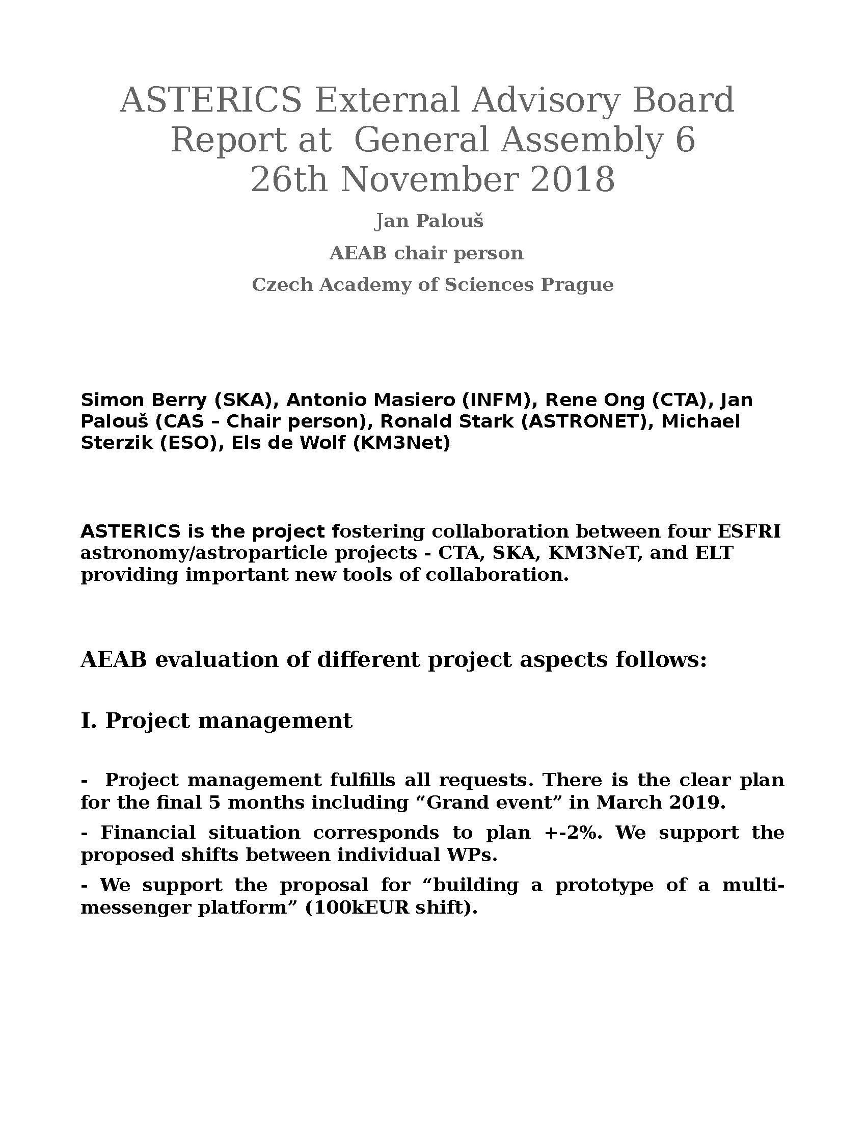
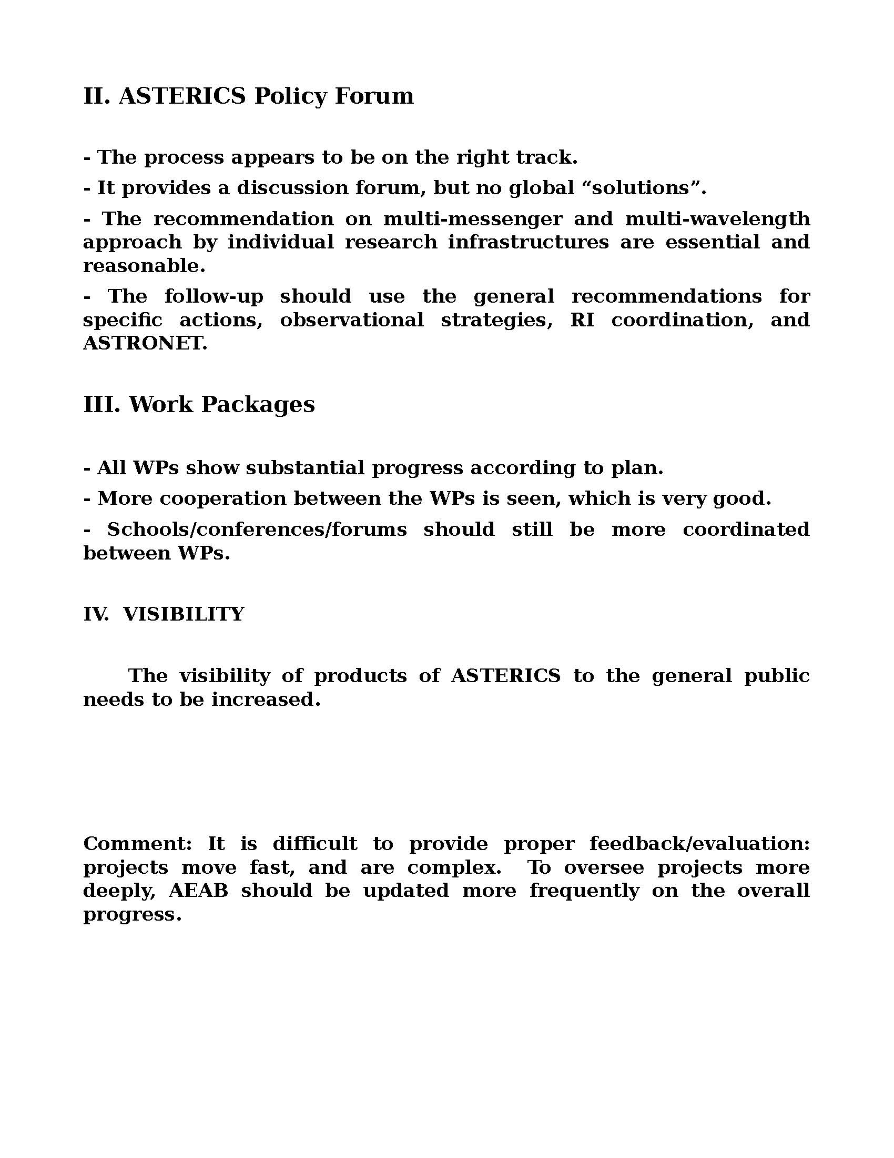

Final report of Policy Forum
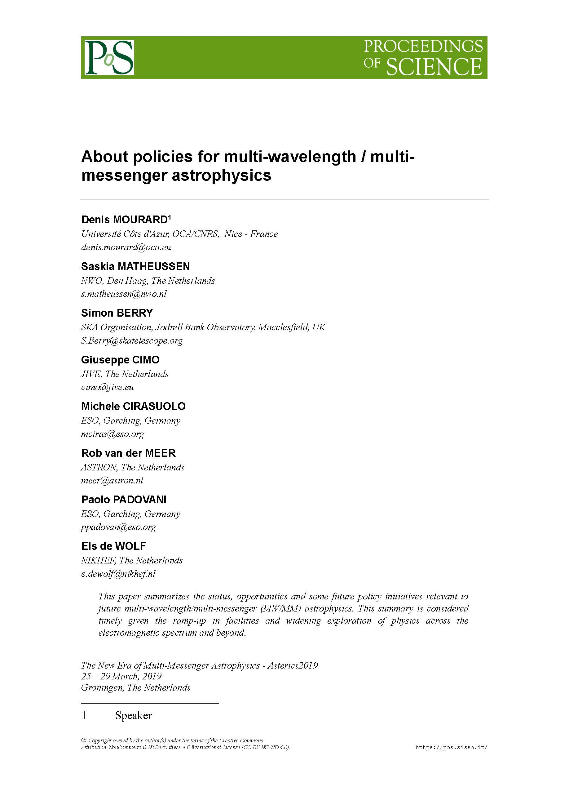
As published in the proceedings of the ASTERICS multi-messenger Astronomy Workshop.

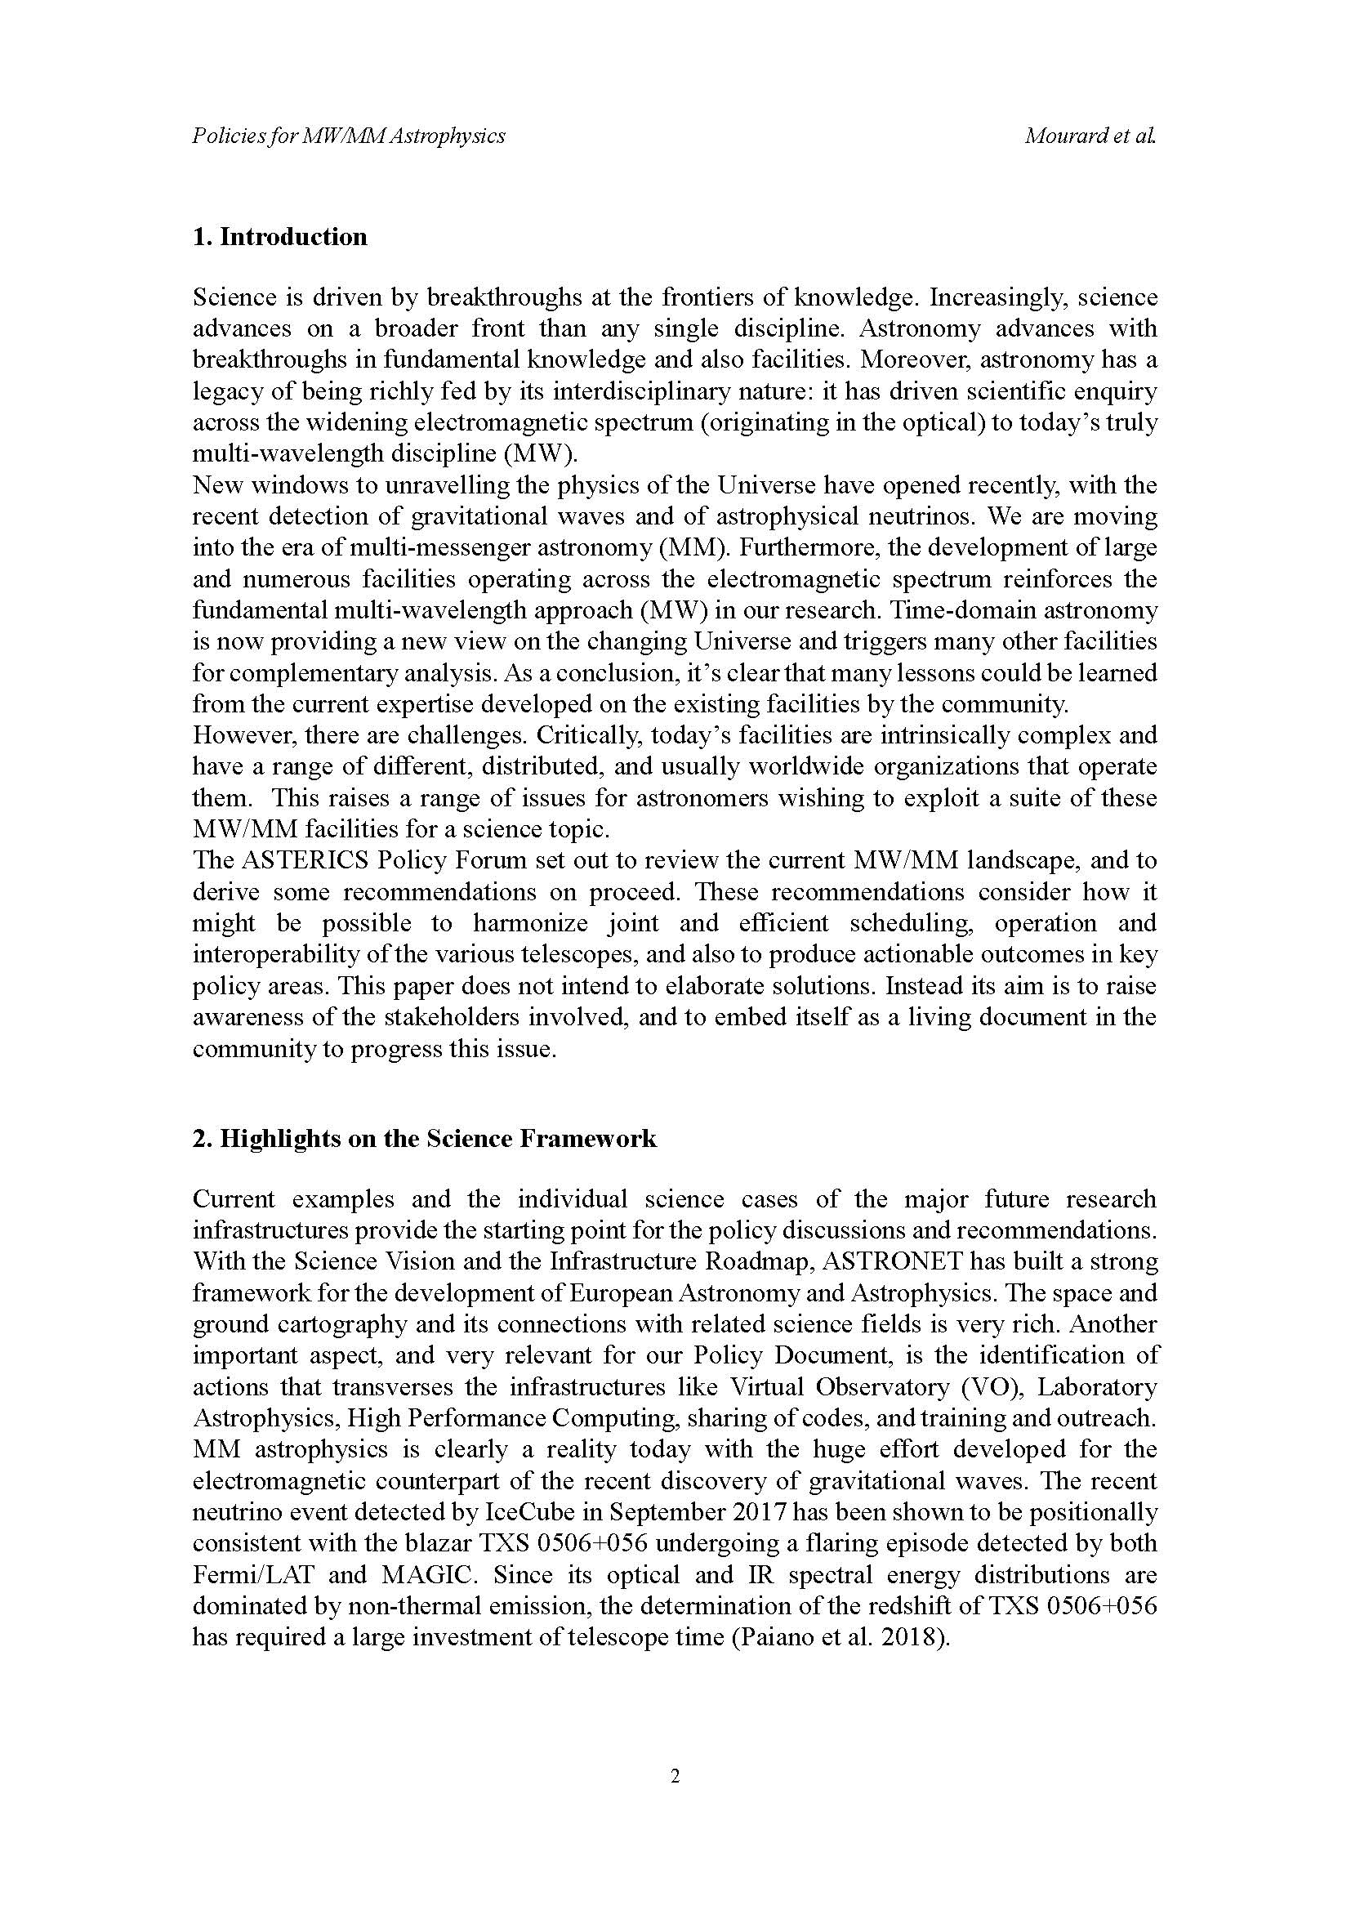
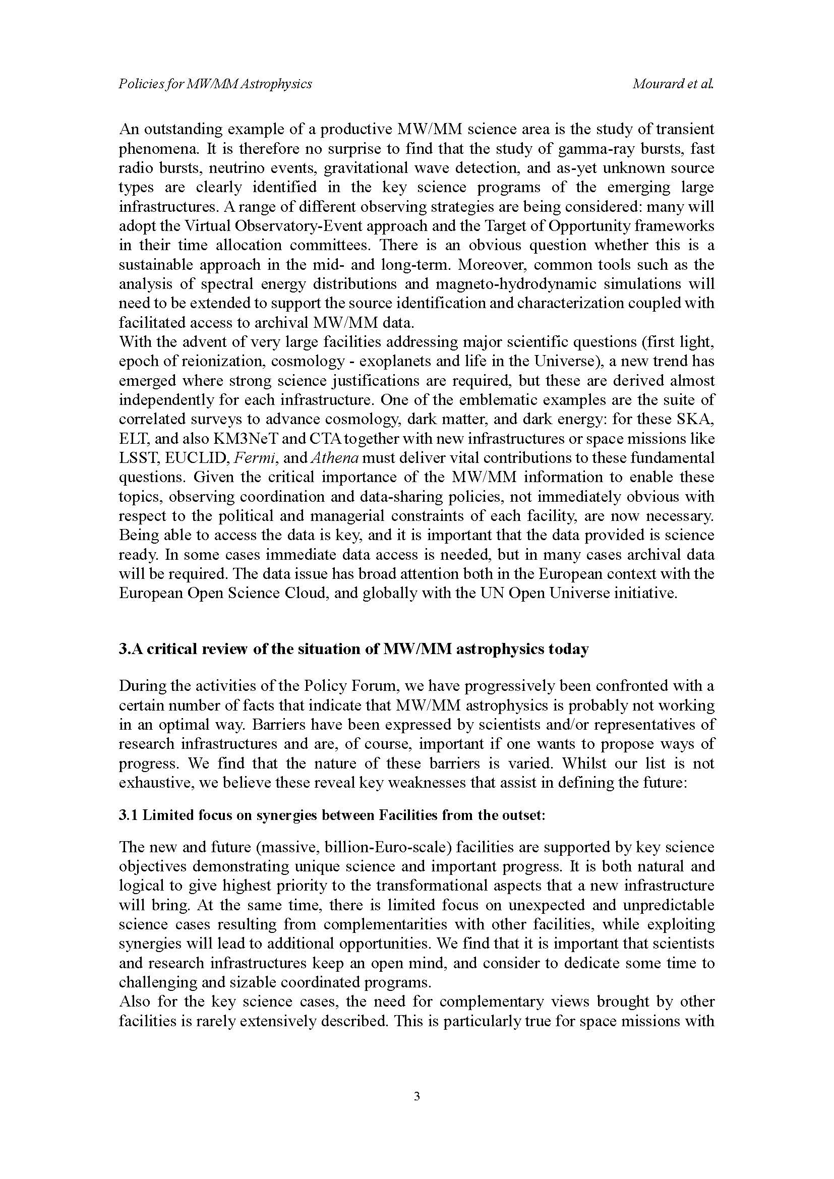
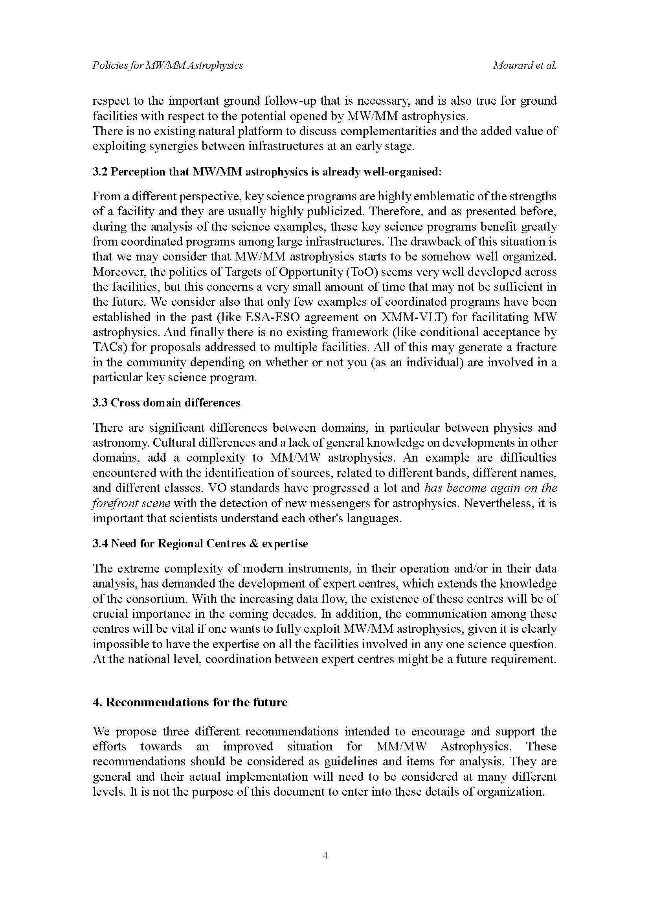
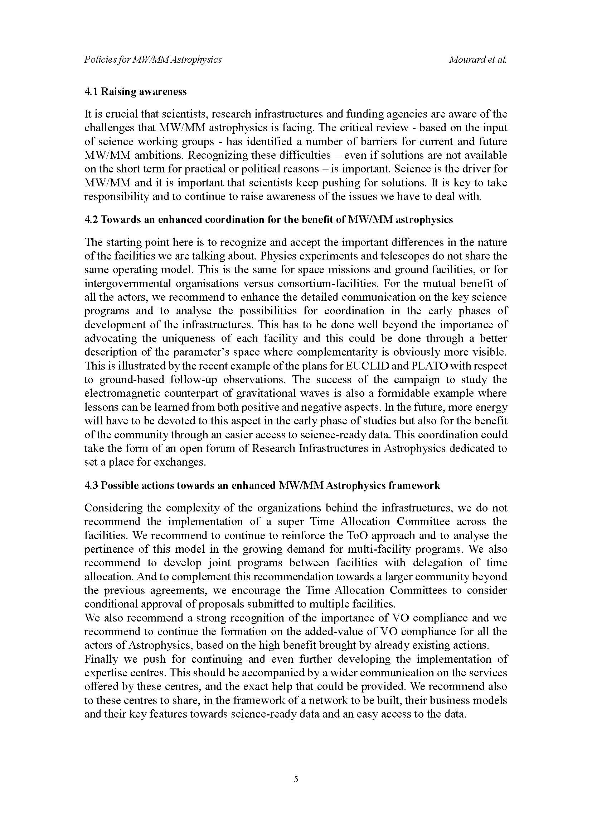
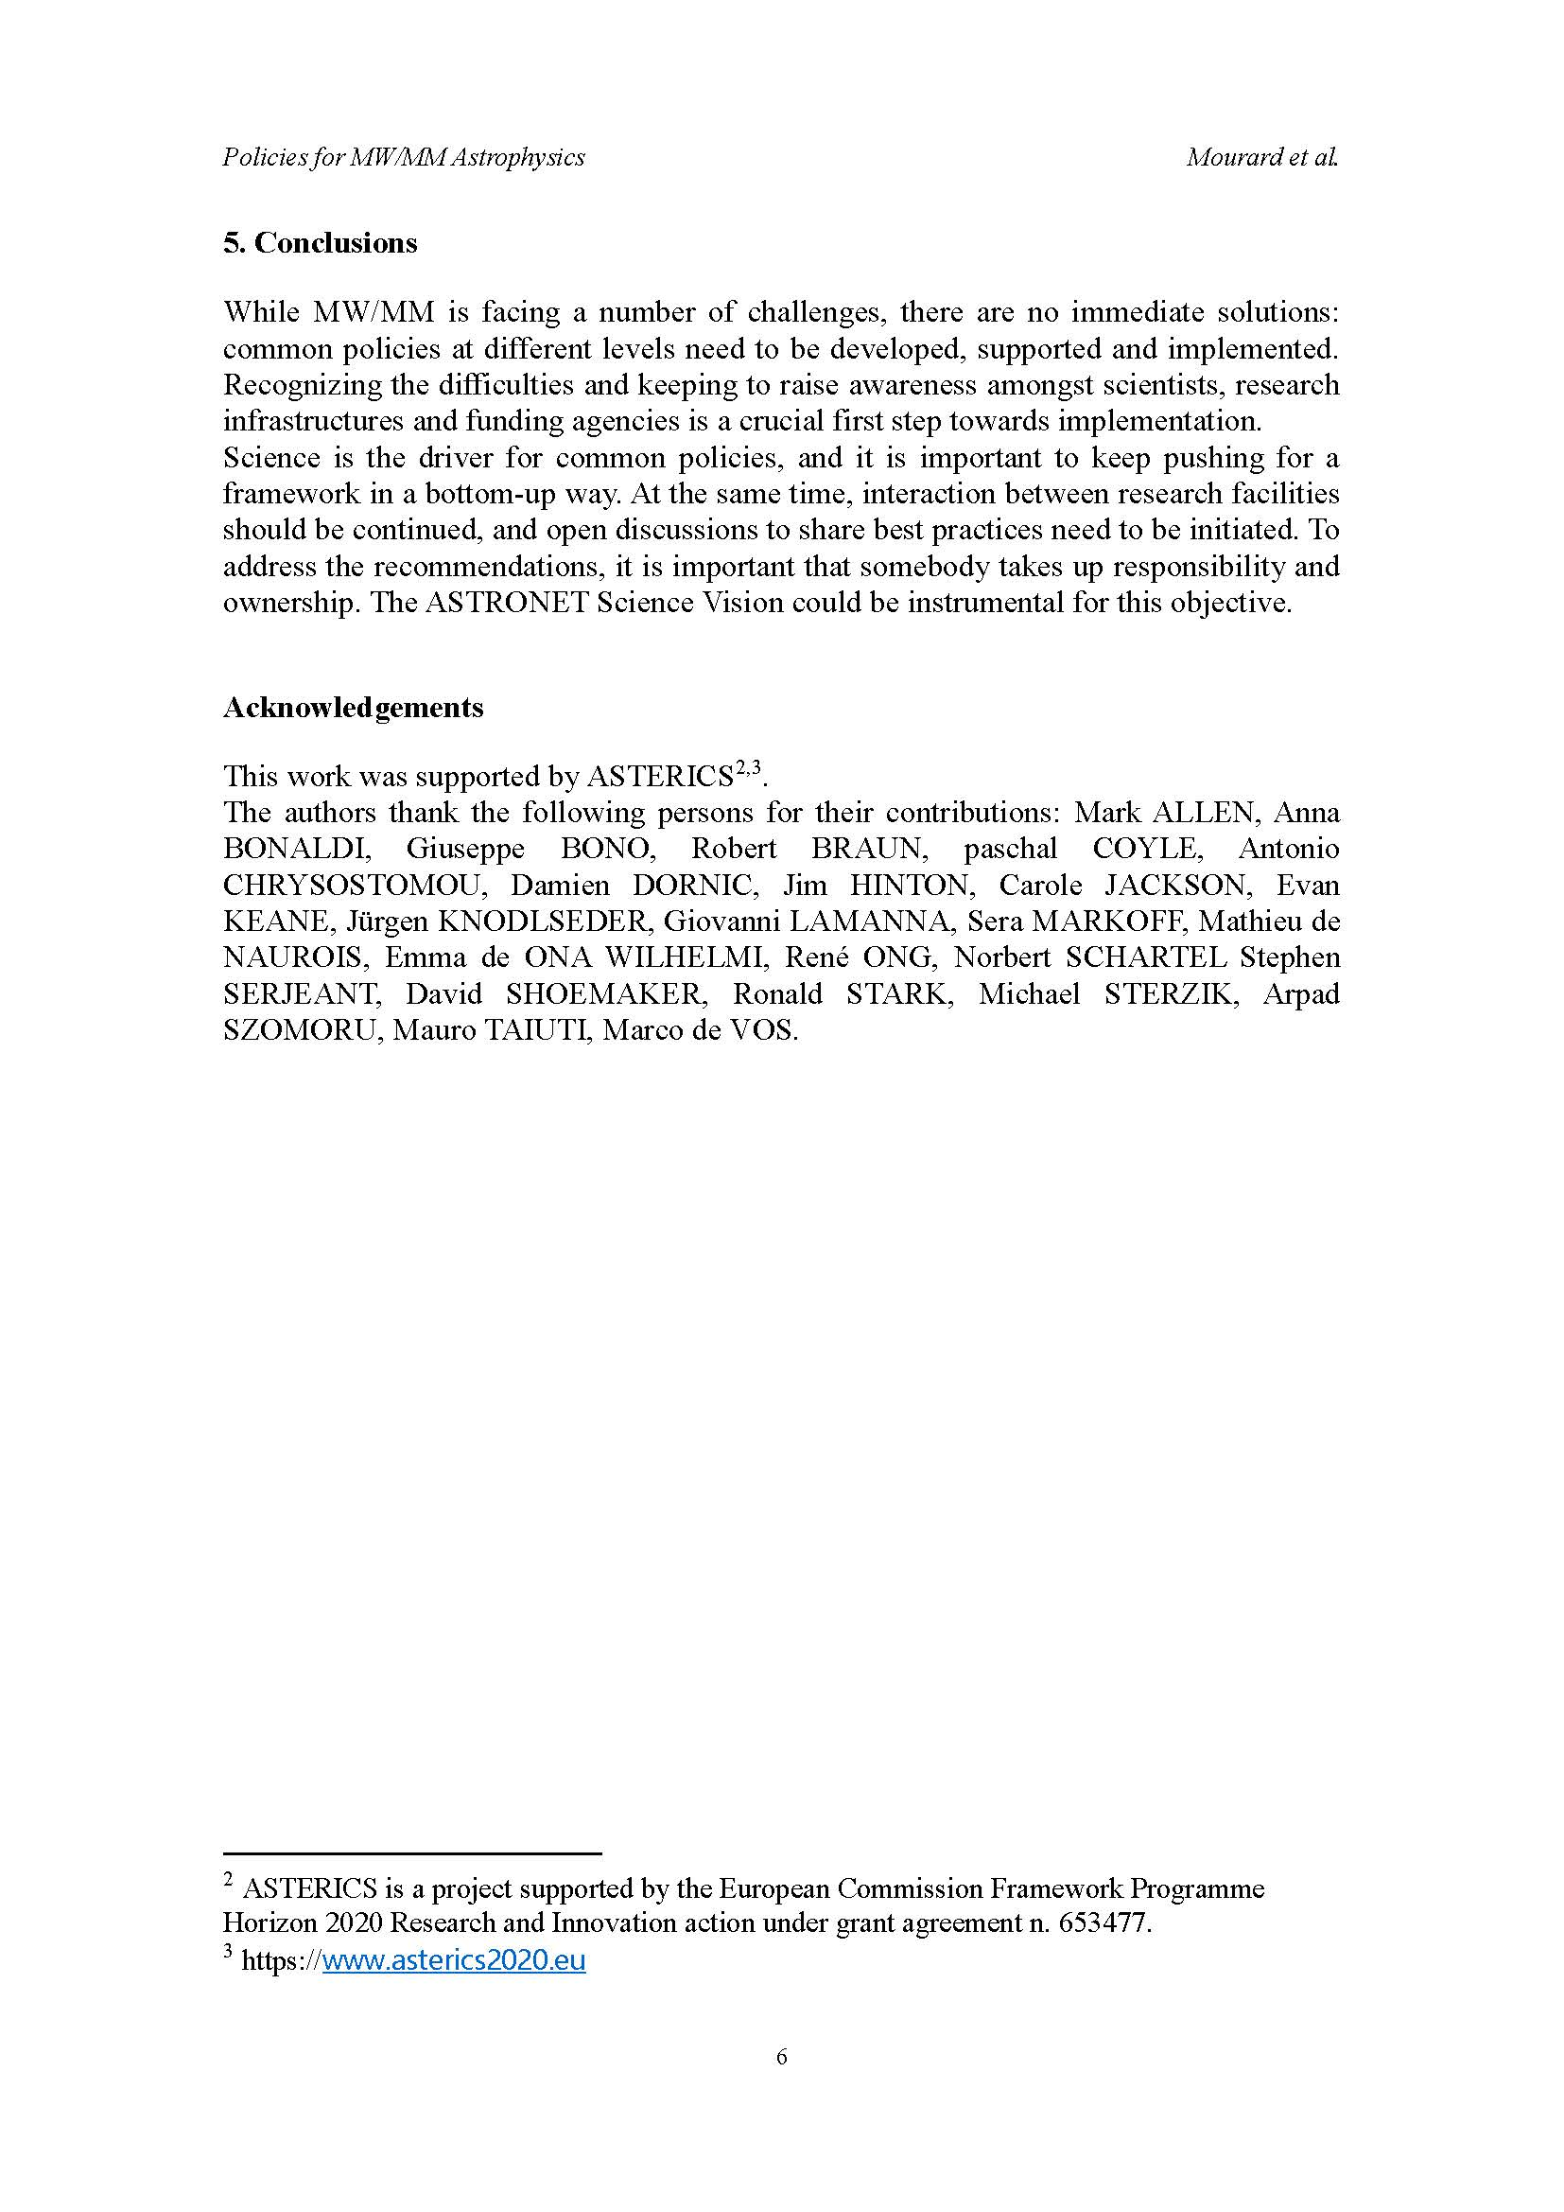

The term ‘project’ used in this template equates to an ‘action’ in certain other Horizon 2020 documentation
https://www.asterics2020.eu/dokuwiki/doku.php?id=open:wp4:start
http://www.g-vo.org/edp-forum-2018
https://www.asterics2020.eu/dokuwiki/doku.php?id=open:wp4:school4
http://www.euro-vo.org/?q=science/scientific-tutorials
https://www.asterics2020.eu/dokuwiki/doku.php?id=open:wp4:wp4techforum5
https://www.asterics2020.eu/dokuwiki/doku.php?id=open:wp4:timeseriesdatameeting
https://wiki.ivoa.net/twiki/bin/view/IVOA/ProvDayAug2018
https://www.asterics2020.eu/dokuwiki/doku.php?id=open:wp4:wp4exodm
https://www.asterics2020.eu/dokuwiki/doku.php?id=open:wp4:authnauthzf2f
https://indico.cern.ch/event/783425/
http://wiki.ivoa.net/twiki/bin/view/IVOA/InterOpMay2018MeetingtPage
http://wiki.ivoa.net/twiki/bin/view/IVOA/InterOpNov2018MeetingPage
http://adass2018.umd.edu/
https://www.rd-alliance.org/plenaries/rdas-12th-plenary-meeting-part-international-data-week-2018-gaborone-botswana
http://www.internationaldataweek.org/
https://rd-alliance.org/plenaries/rdas-13th-plenary-meeting-philadelphia-us
https://astronomy2018.univie.ac.at/
https://wiki.ivoa.net/internal/IVOA/IAUAug2018/vo_IAFRATE_IAU_2018.pdf
http://multi-messenger.asterics2020.eu/index.php
Genova, F., et al., Euro-VO – Coordination of virtual observatory activities in Europe, Astronomy and Computing, Vol. 1, pp. 181-189, 2015, http://dx.doi.org/10.1016/j.ascom.2015.03.001
VIRGO/EGO/ET is not on the ESFRI Roadmap but was involved as a partner as a facility of pan-European interest
GWSky is a Python tool developed in the framework of the LIGO-VIRGO collaboration, proposed to the Gravitational Wave community for gravitational wave follow-up. http://www.virgo-gw.eu/skymap.html
Romaniello, M., et al., Enhanced Data Discovery Services for the ESO Science Archive, The Messenger, vol. 172, pp. 2-7, 2018, http://doi.eso.org/10.18727/0722-6691/5073
https://wiki.ivoa.net/twiki/bin/view/IVOA/IVOAHistoryPage#workinggroups

